Project Overview:

This project involves hosting a resume on an AWS S3 bucket as a static website and accessing it through a Route 53 custom domain and CloudFront.

Prerequisites:

* An AWS account.
* A Route 53 custom domain.

**Project Architecture:**

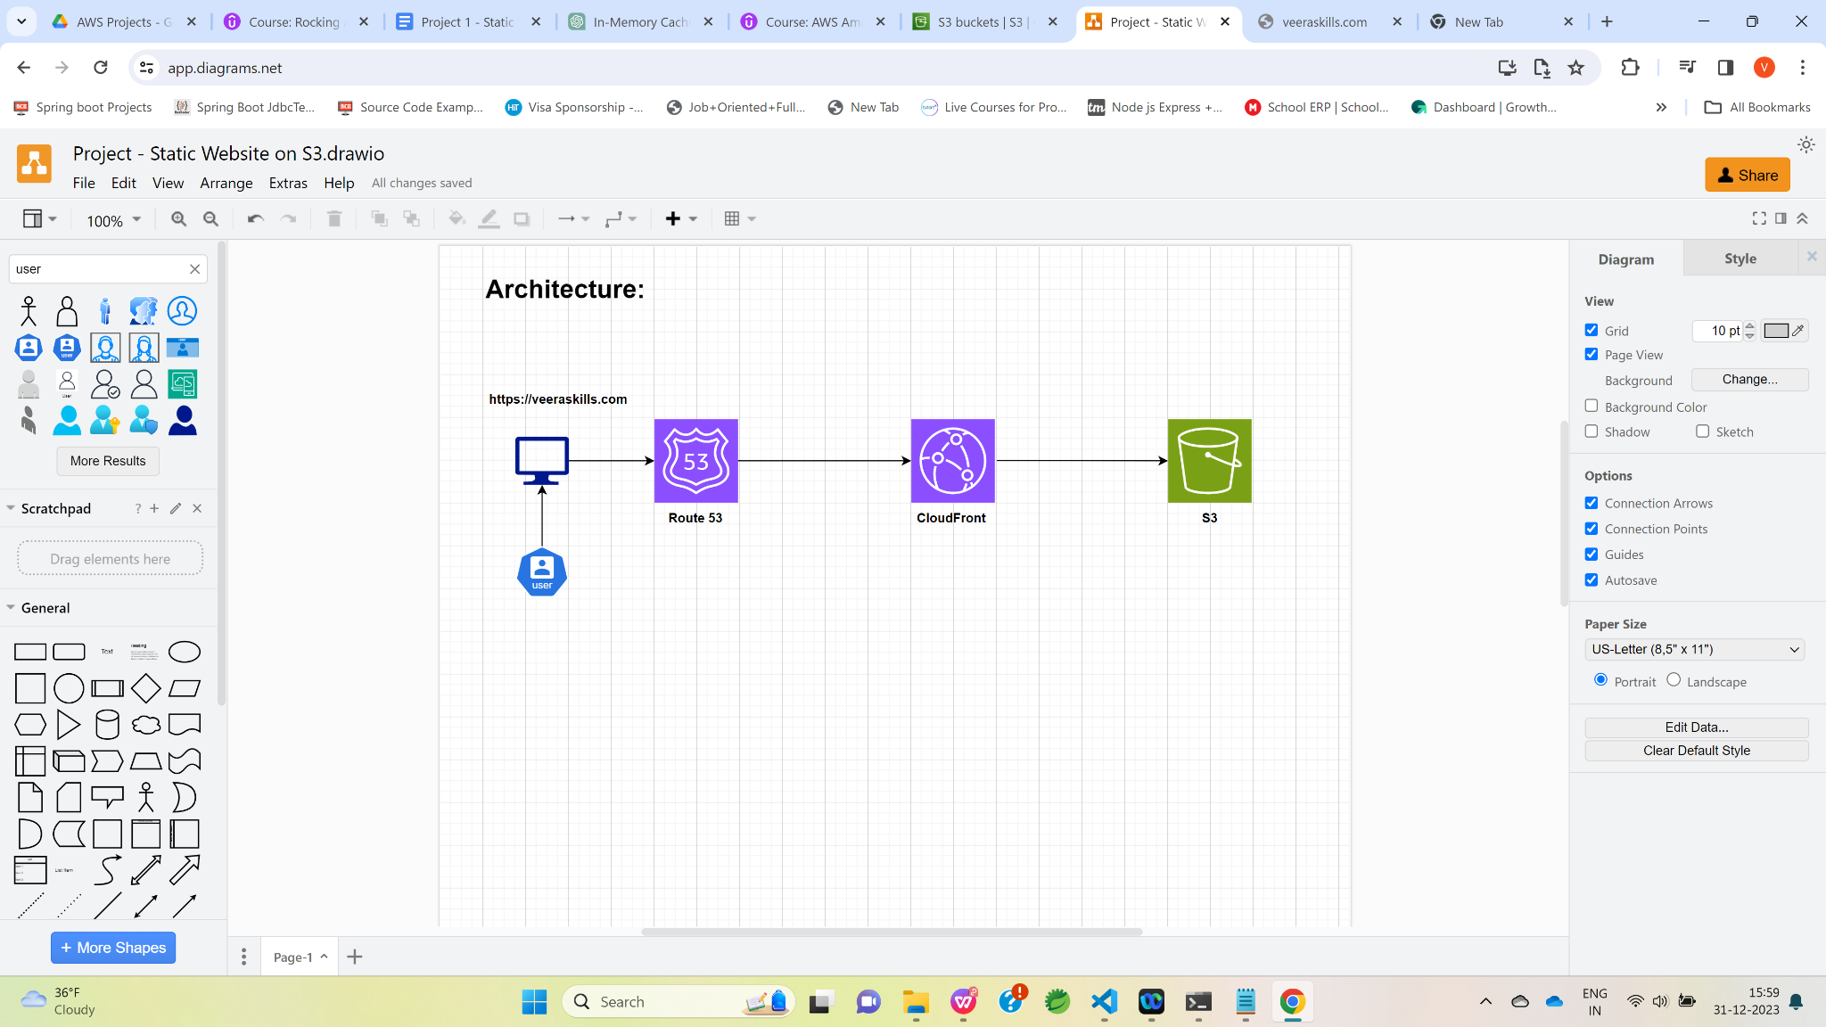

Steps: Creating an S3 Bucket

* Go to the AWS Management Console.
* Click on the "Services" dropdown.
* Under the "Storage" category, select the "S3" icon.

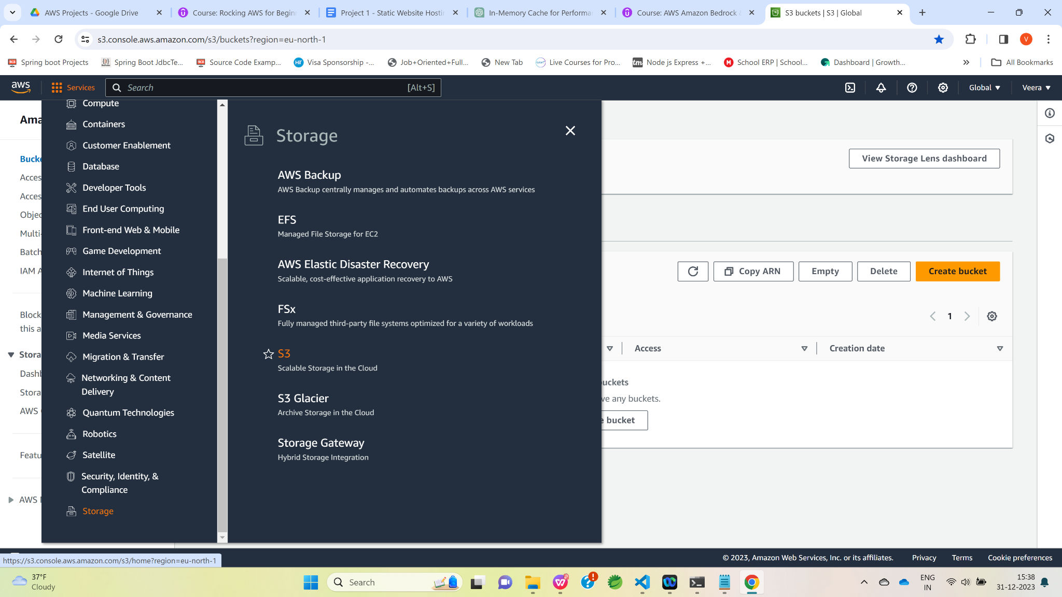

Click on the “Create bucket” button.

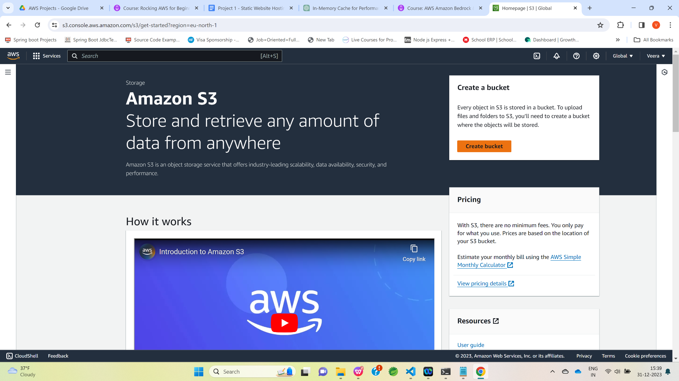

Select the region from “AWS Region” dropdown

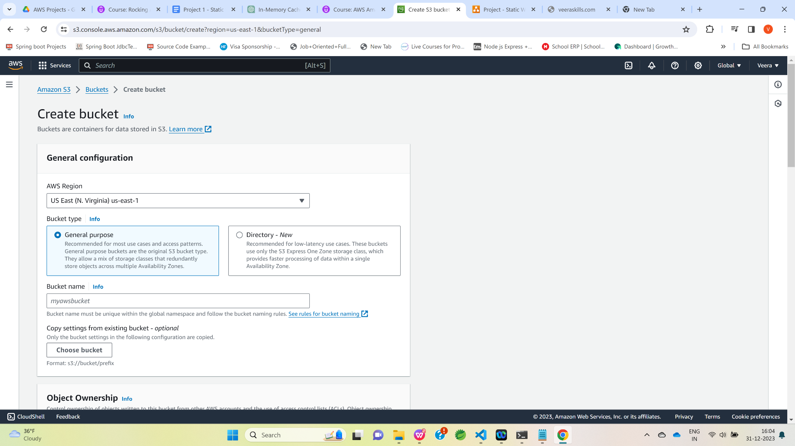

Enter the desired S3 bucket name, such as "s3-static-website-001" (Note: S3 bucket names must be unique across all AWS accounts).

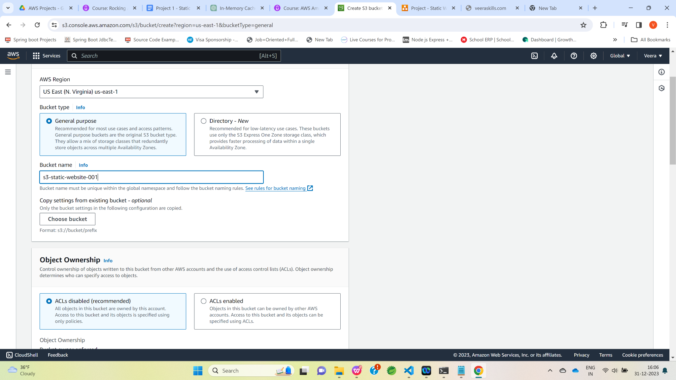

Uncheck the "Block all public access" option and select the "acknowledge" option.

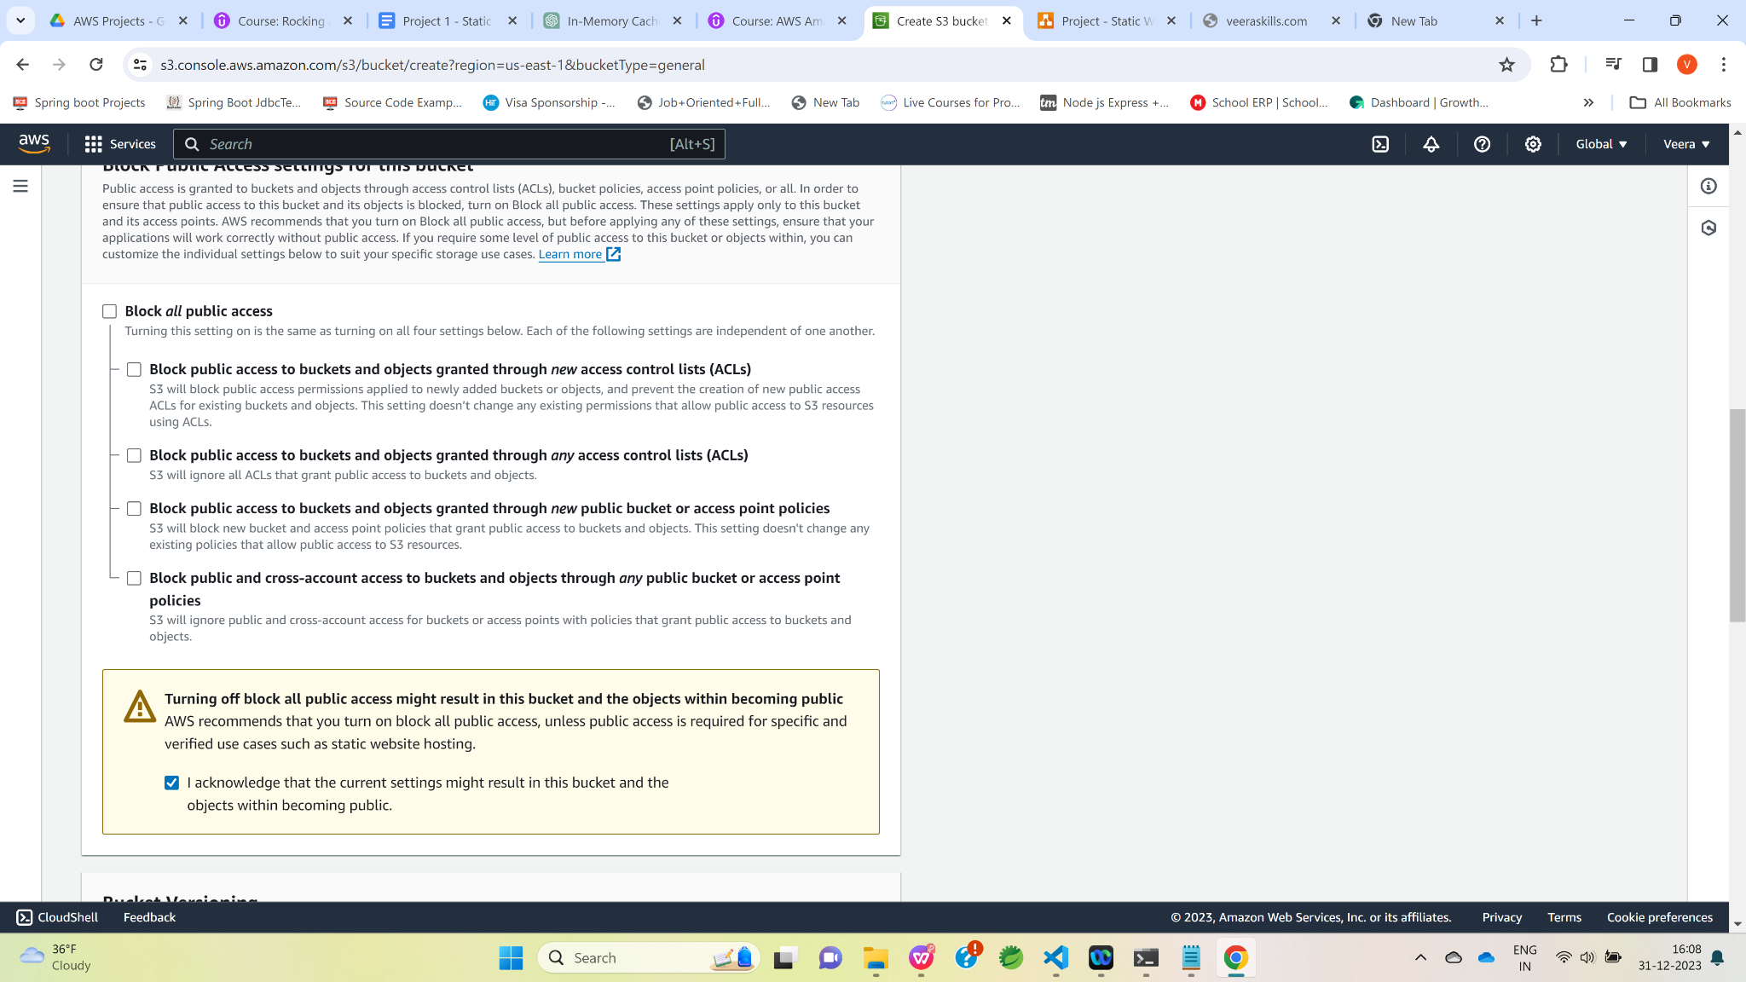

Click on the “Create bucket” button.

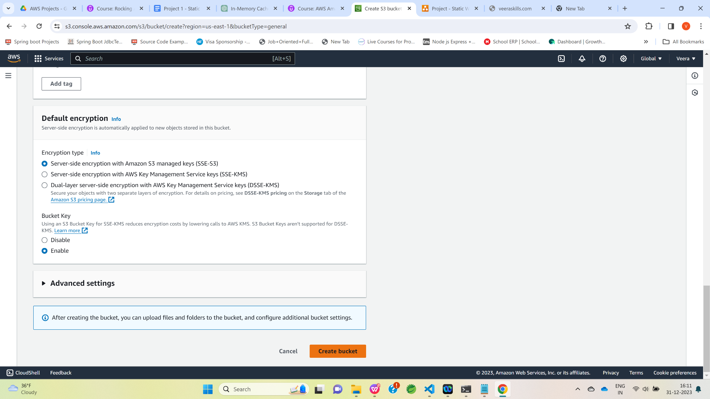

The S3 bucket has been created successfully.

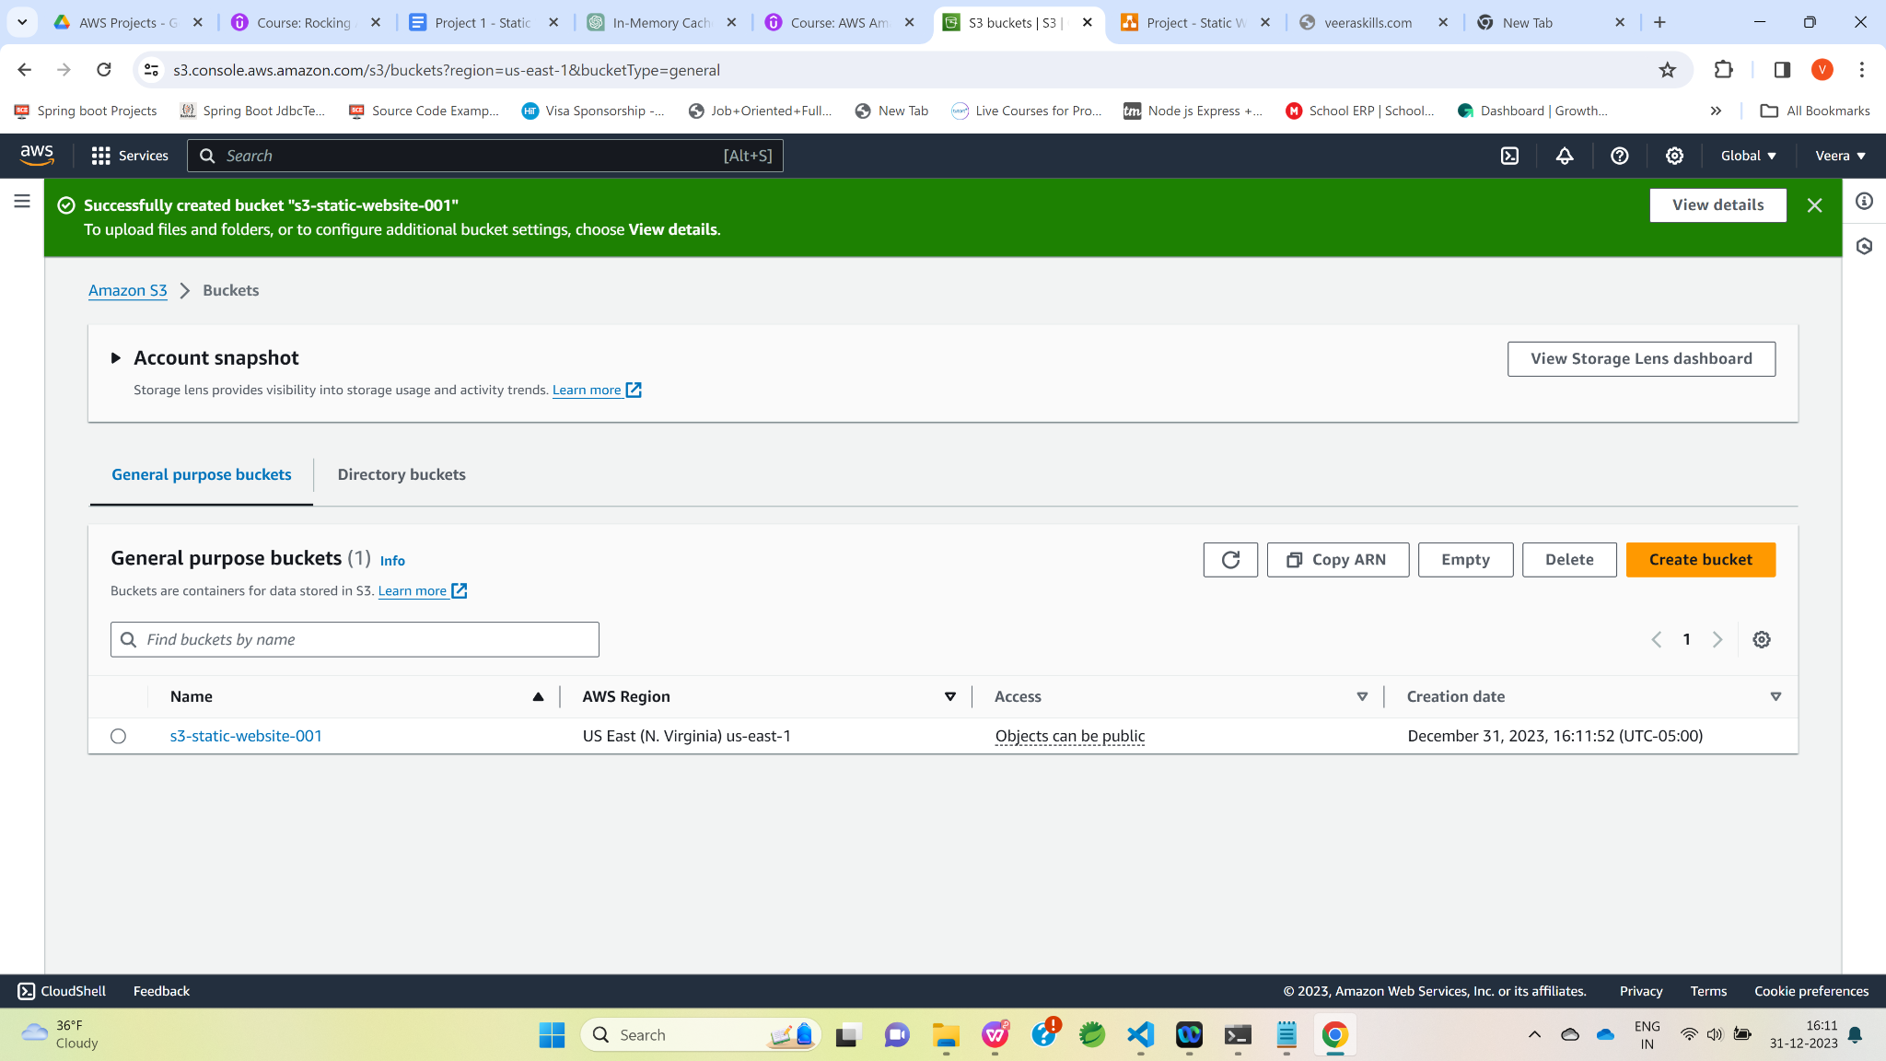

Click on bucket name “[s3-static-website-001](https://s3.console.aws.amazon.com/s3/buckets/s3-static-website-001?region=us-east-1&bucketType=general)” , under the properties tab , click on the “Edit” button of “Static website hosting” section.

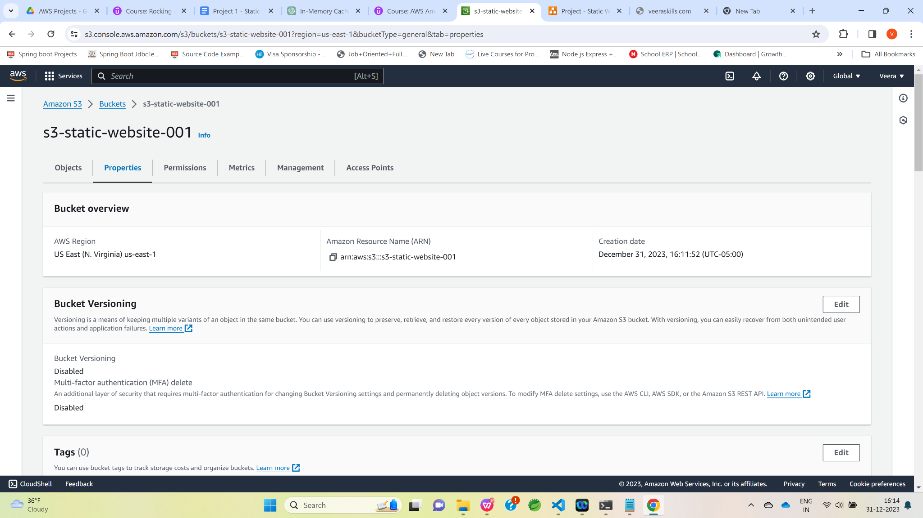

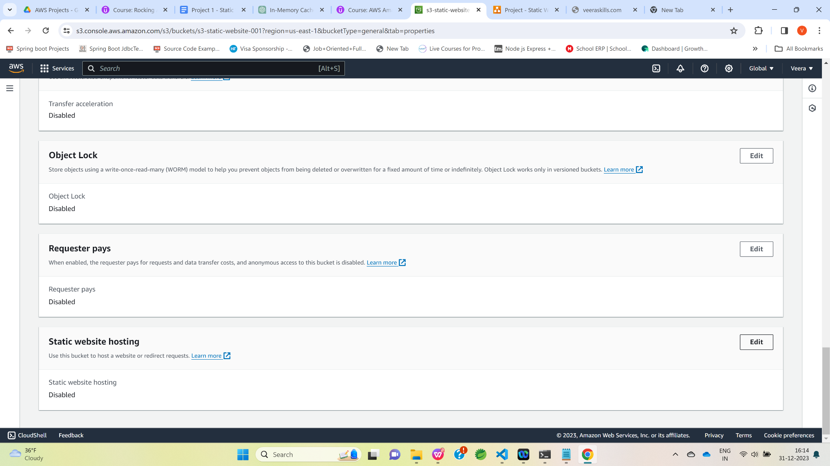

Enable static website hosting.

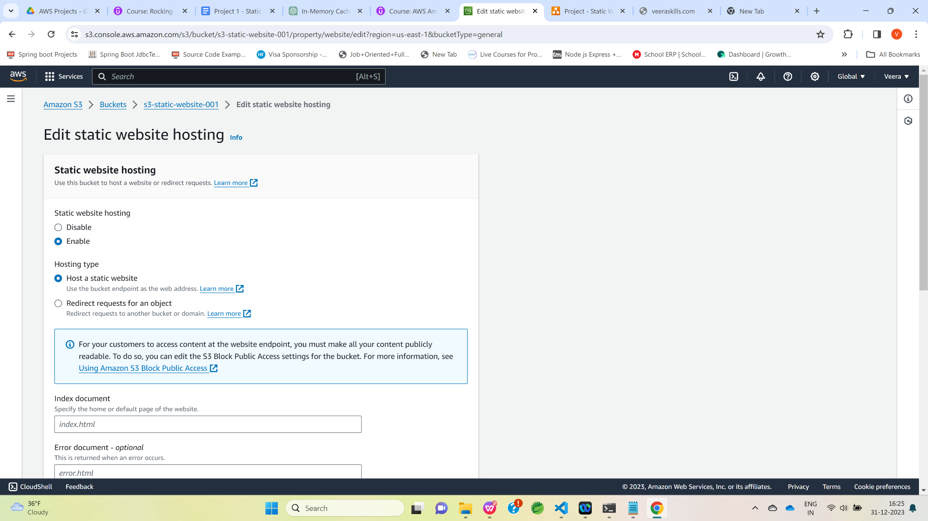

Enter the html file name(Veerababu-Srikakolapu-Resume.html) in the index document textbox.

And, error html file name(error.html) in the error document textbox.

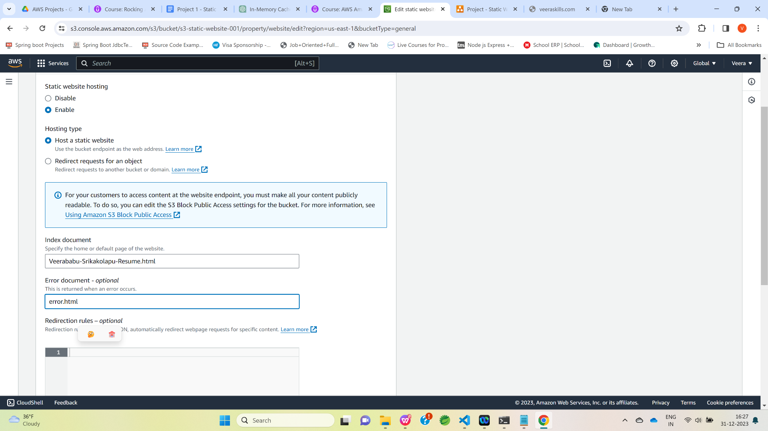

Click on the “Save changes” button.

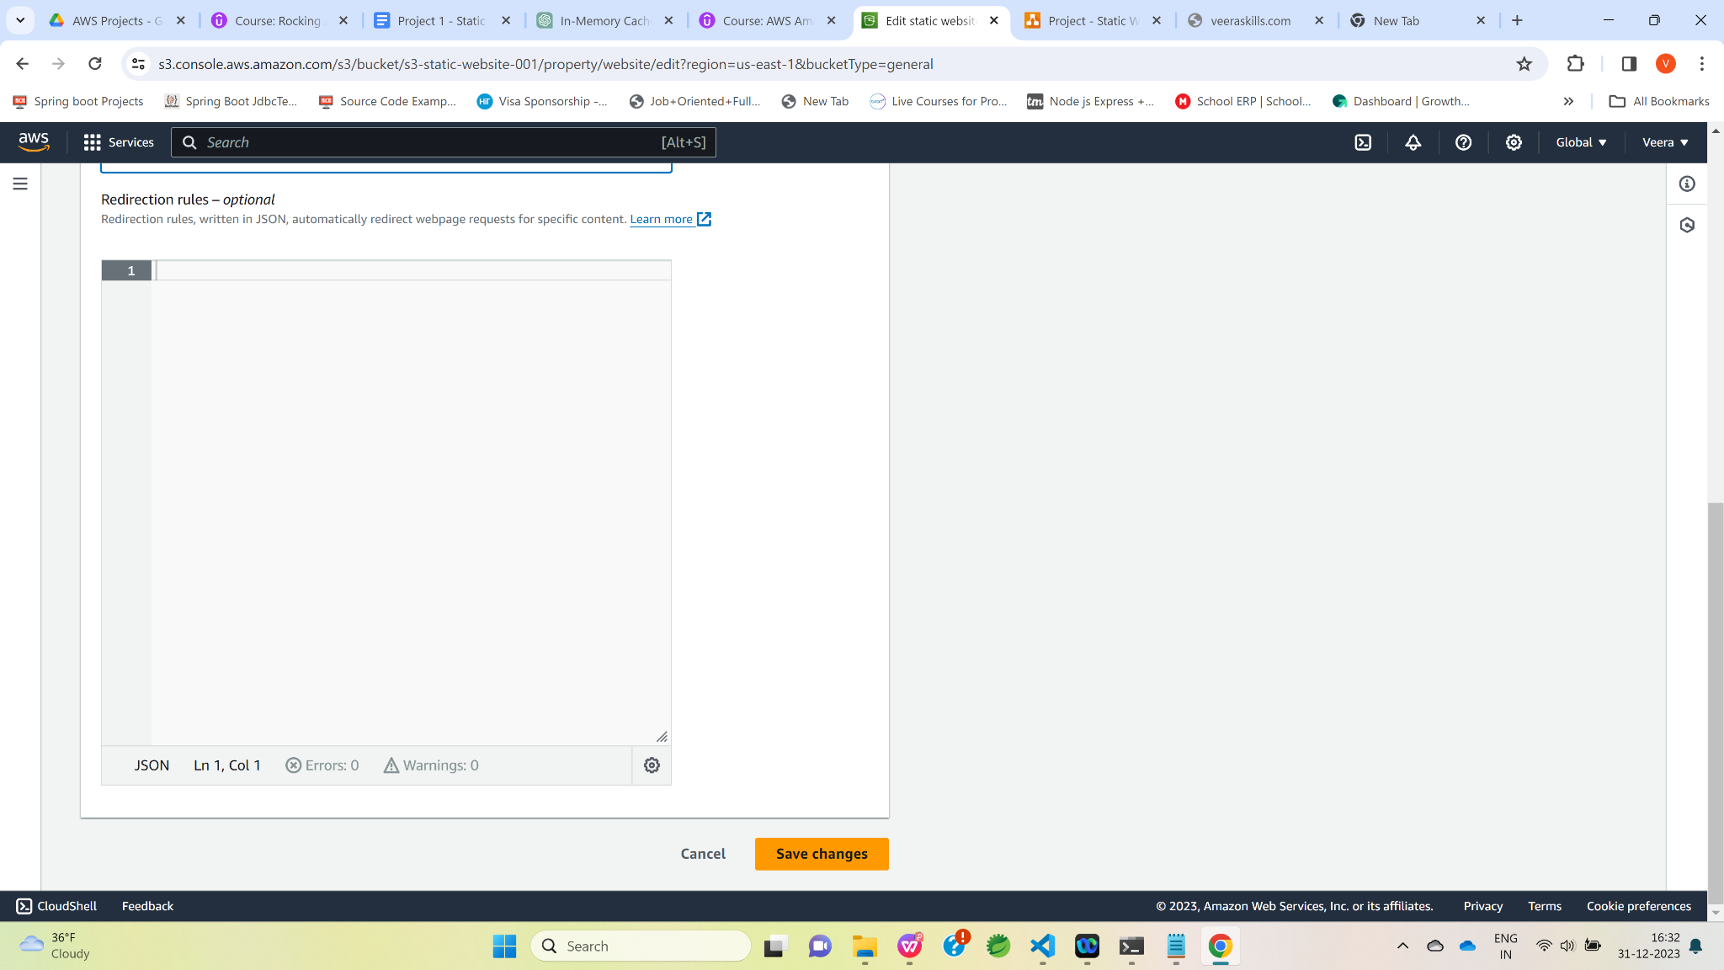

Under the Permissions tab , click on edit buttton of the ”Edit bucket policy section” and add below IAM policy to make S3 bucket as public to read the S3 objects.

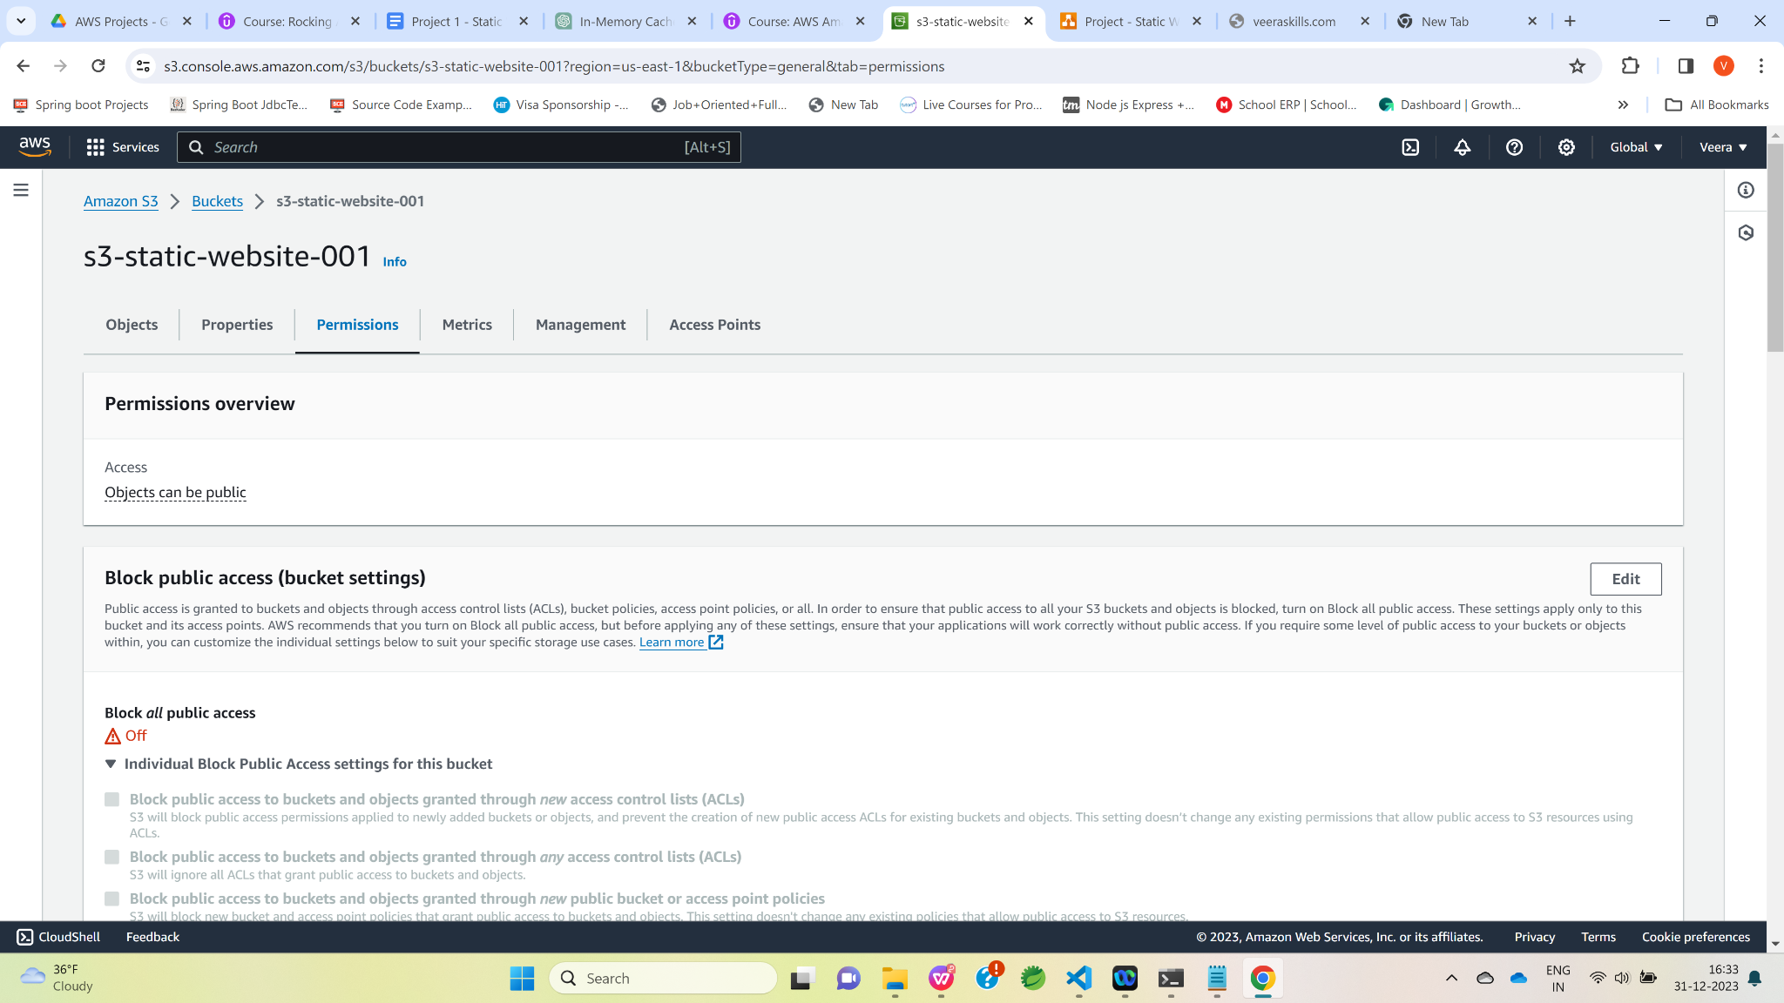

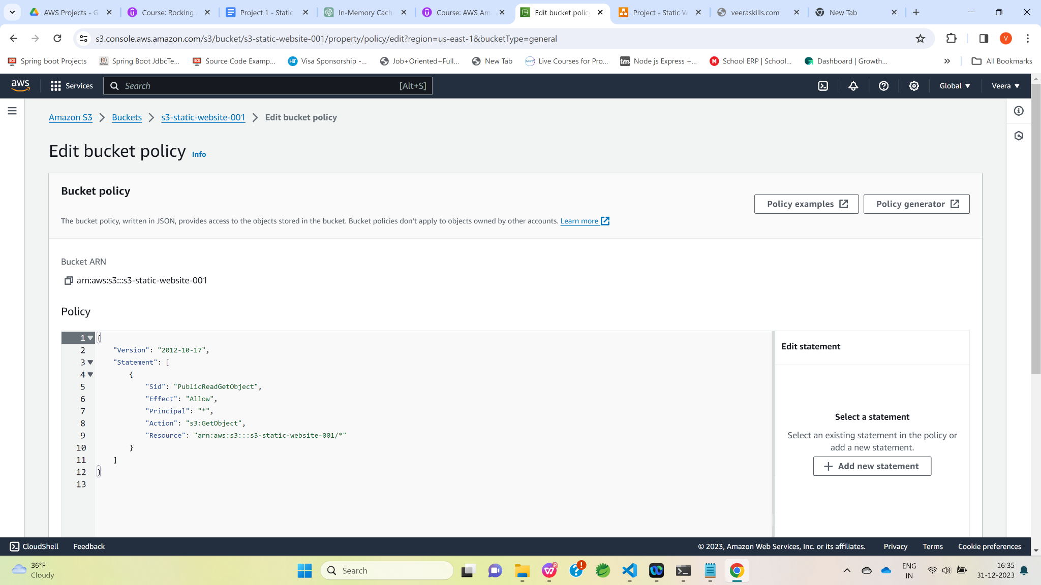

Click on S3 bucket and click on “Upload” button and then click on “Add files” button to upload html file from local system.

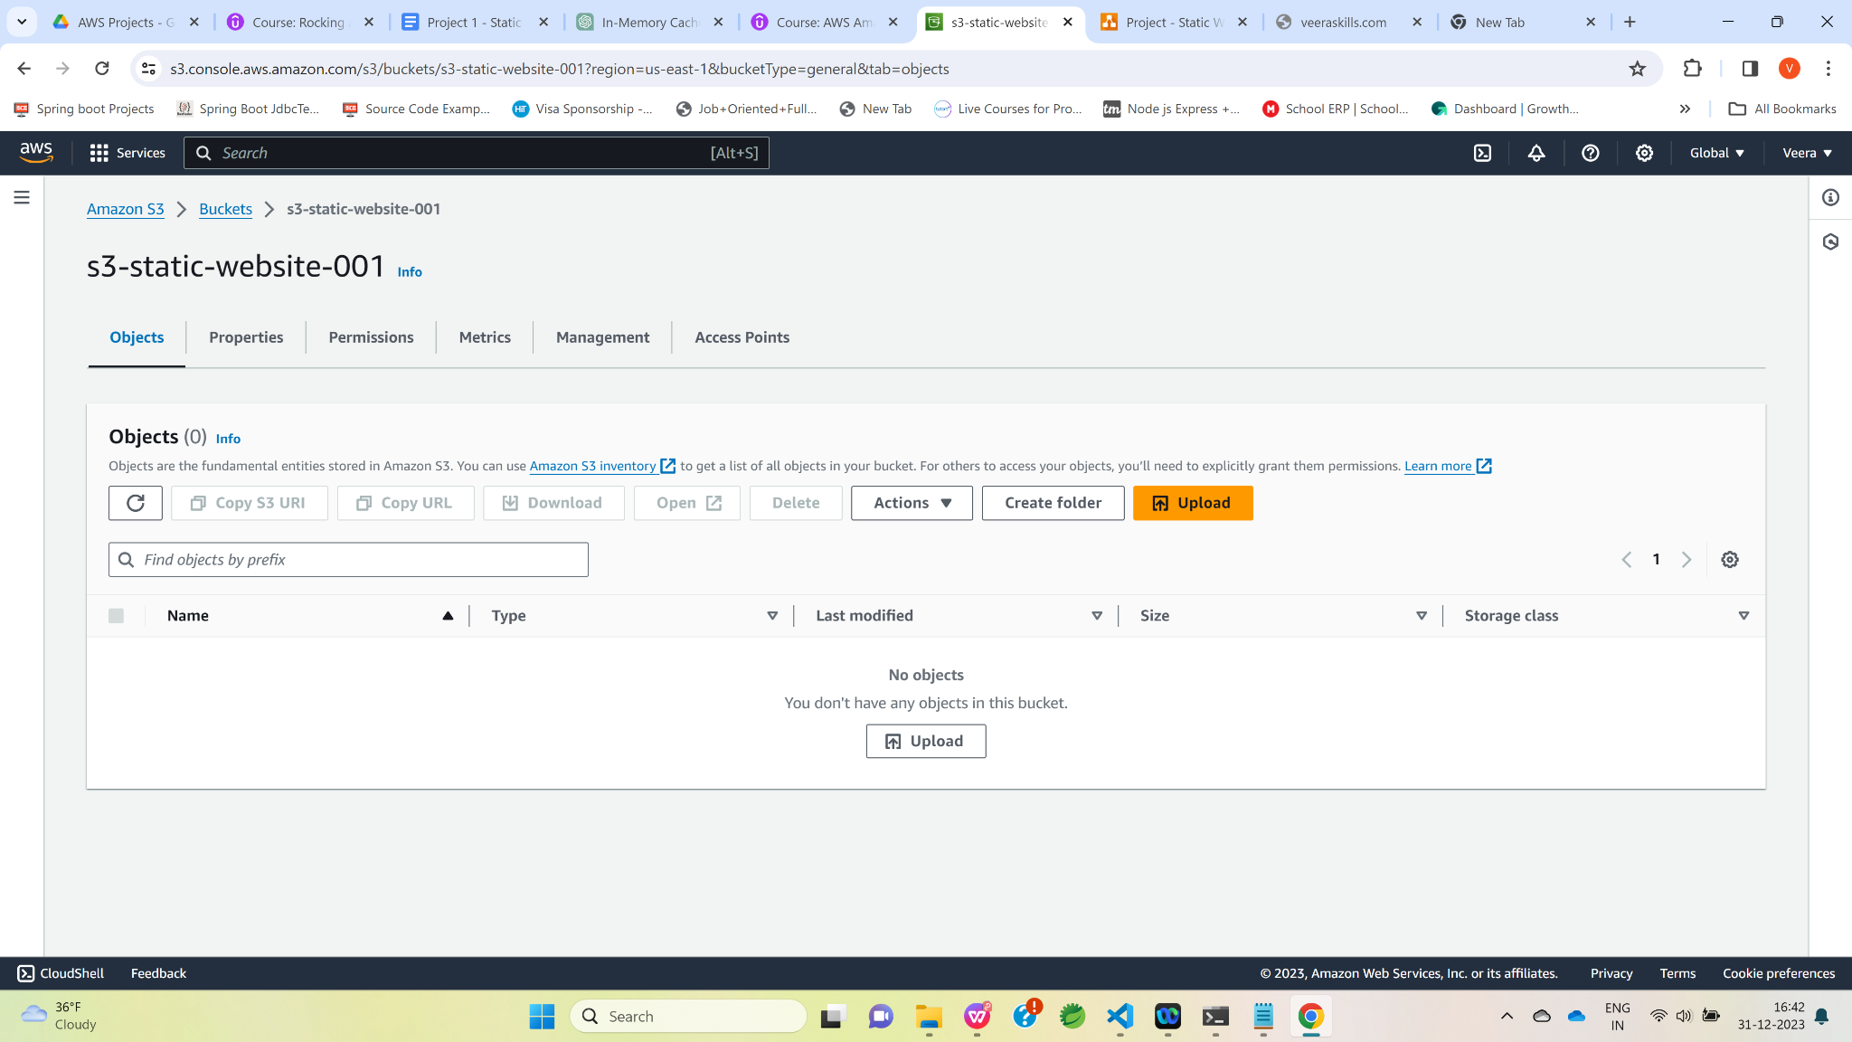

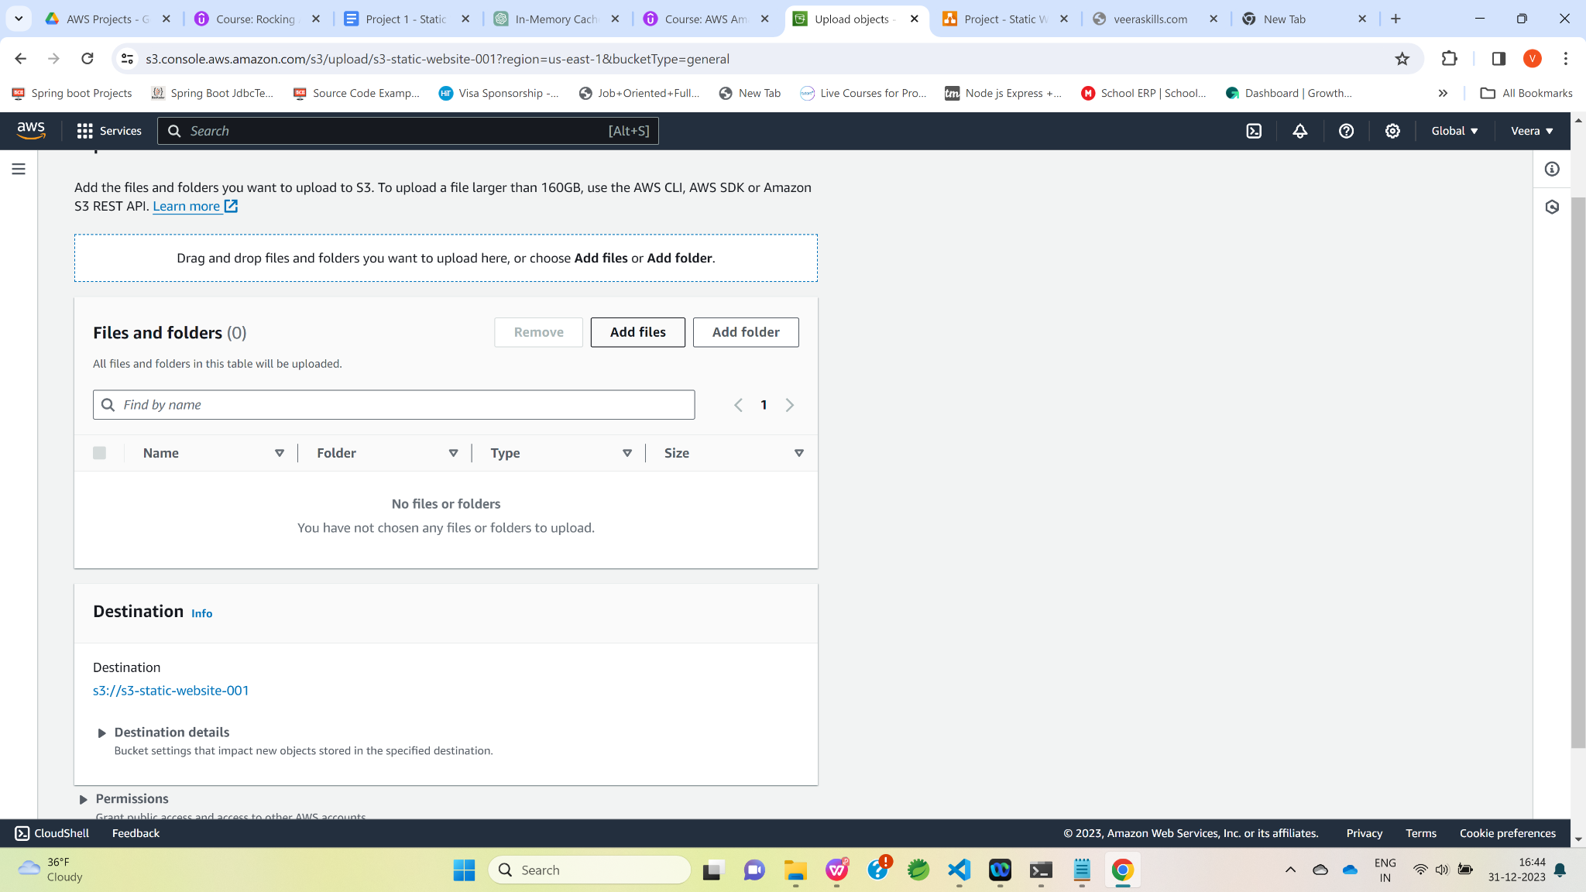

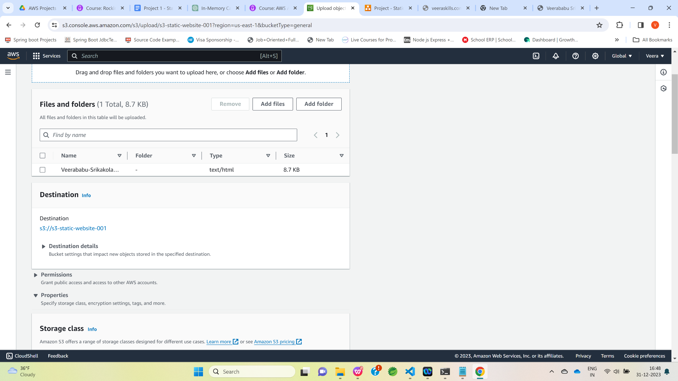

Click on “Upload” button.

Now, html file has been uploaded successfully.

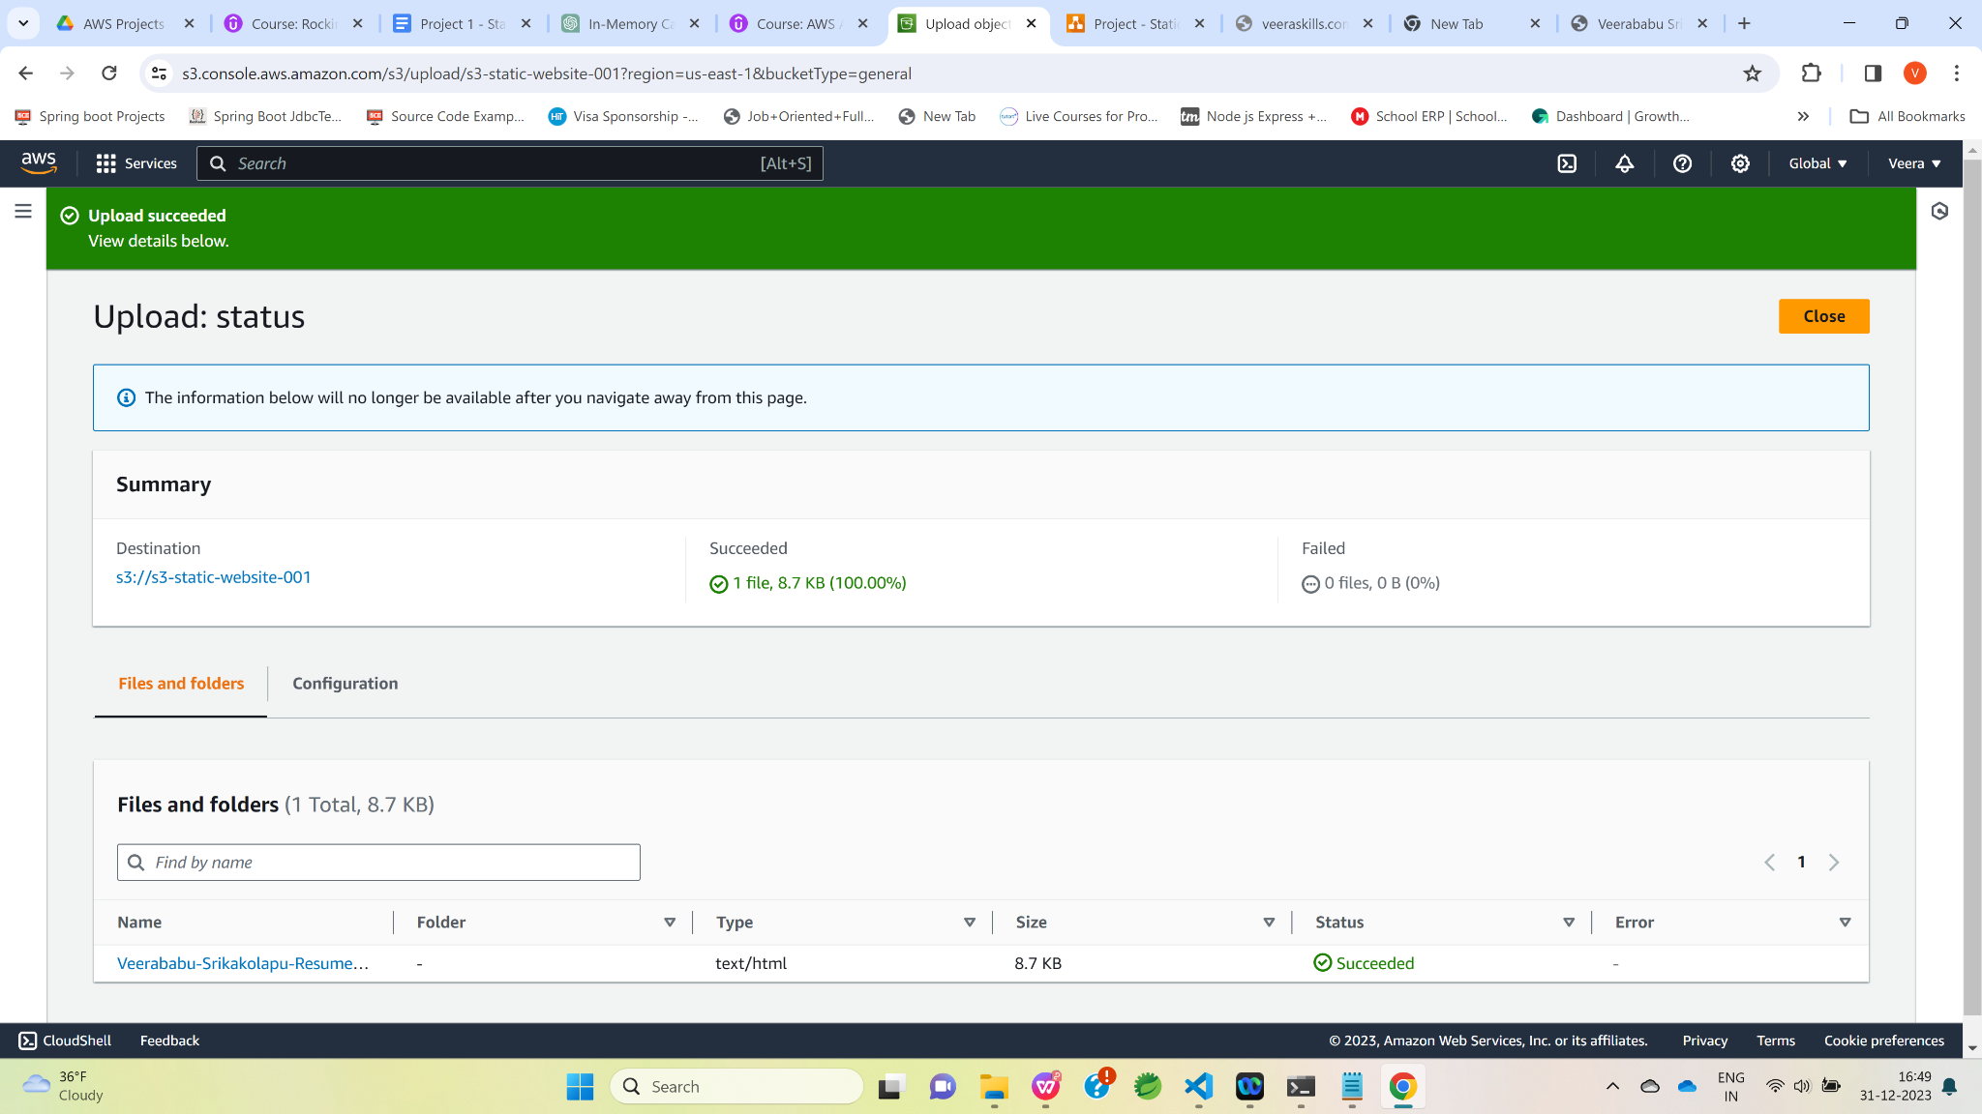

Navigate to properties tab and then click on S3 static website link([**http://s3-static-website-001.s3-website-us-east-1.amazonaws.com**](http://s3-static-website-001.s3-website-us-east-1.amazonaws.com)**)**  in Static website hosting section

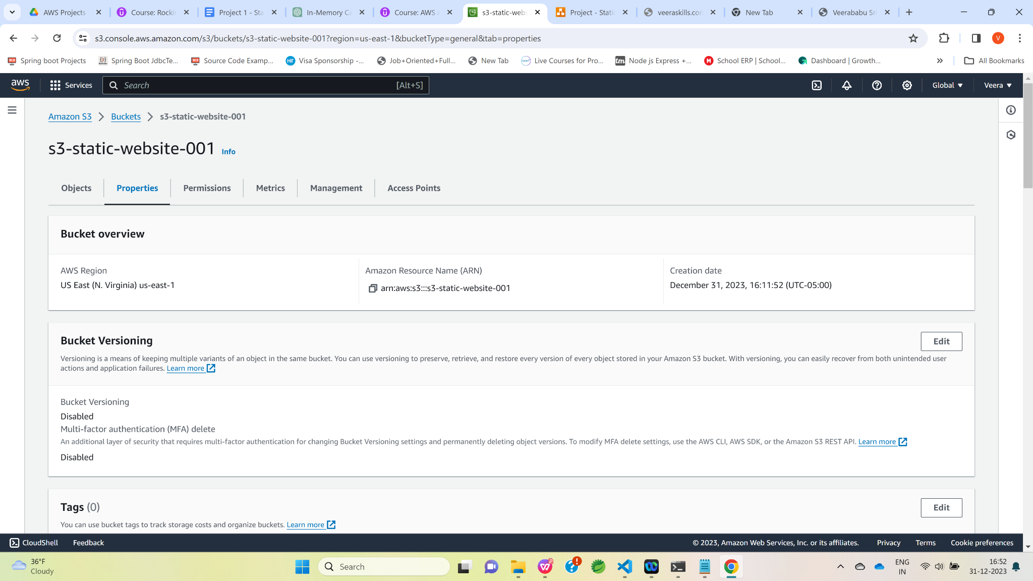

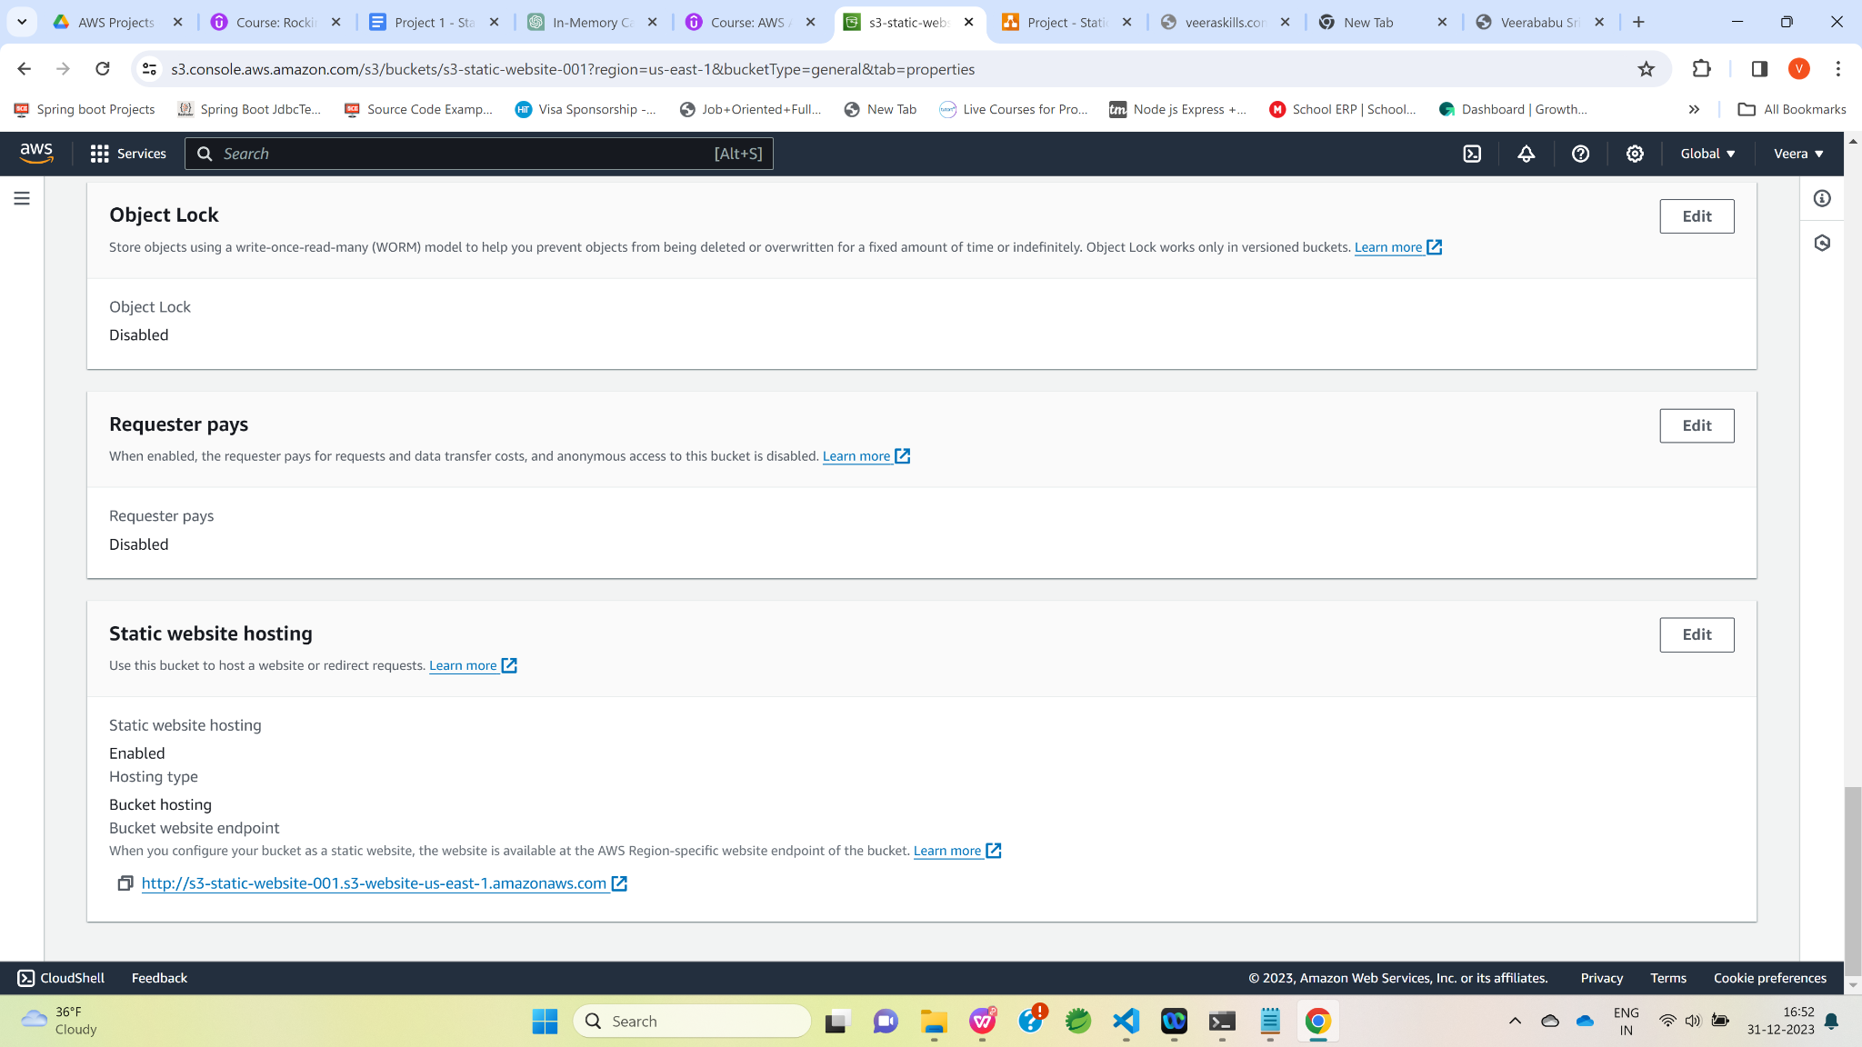

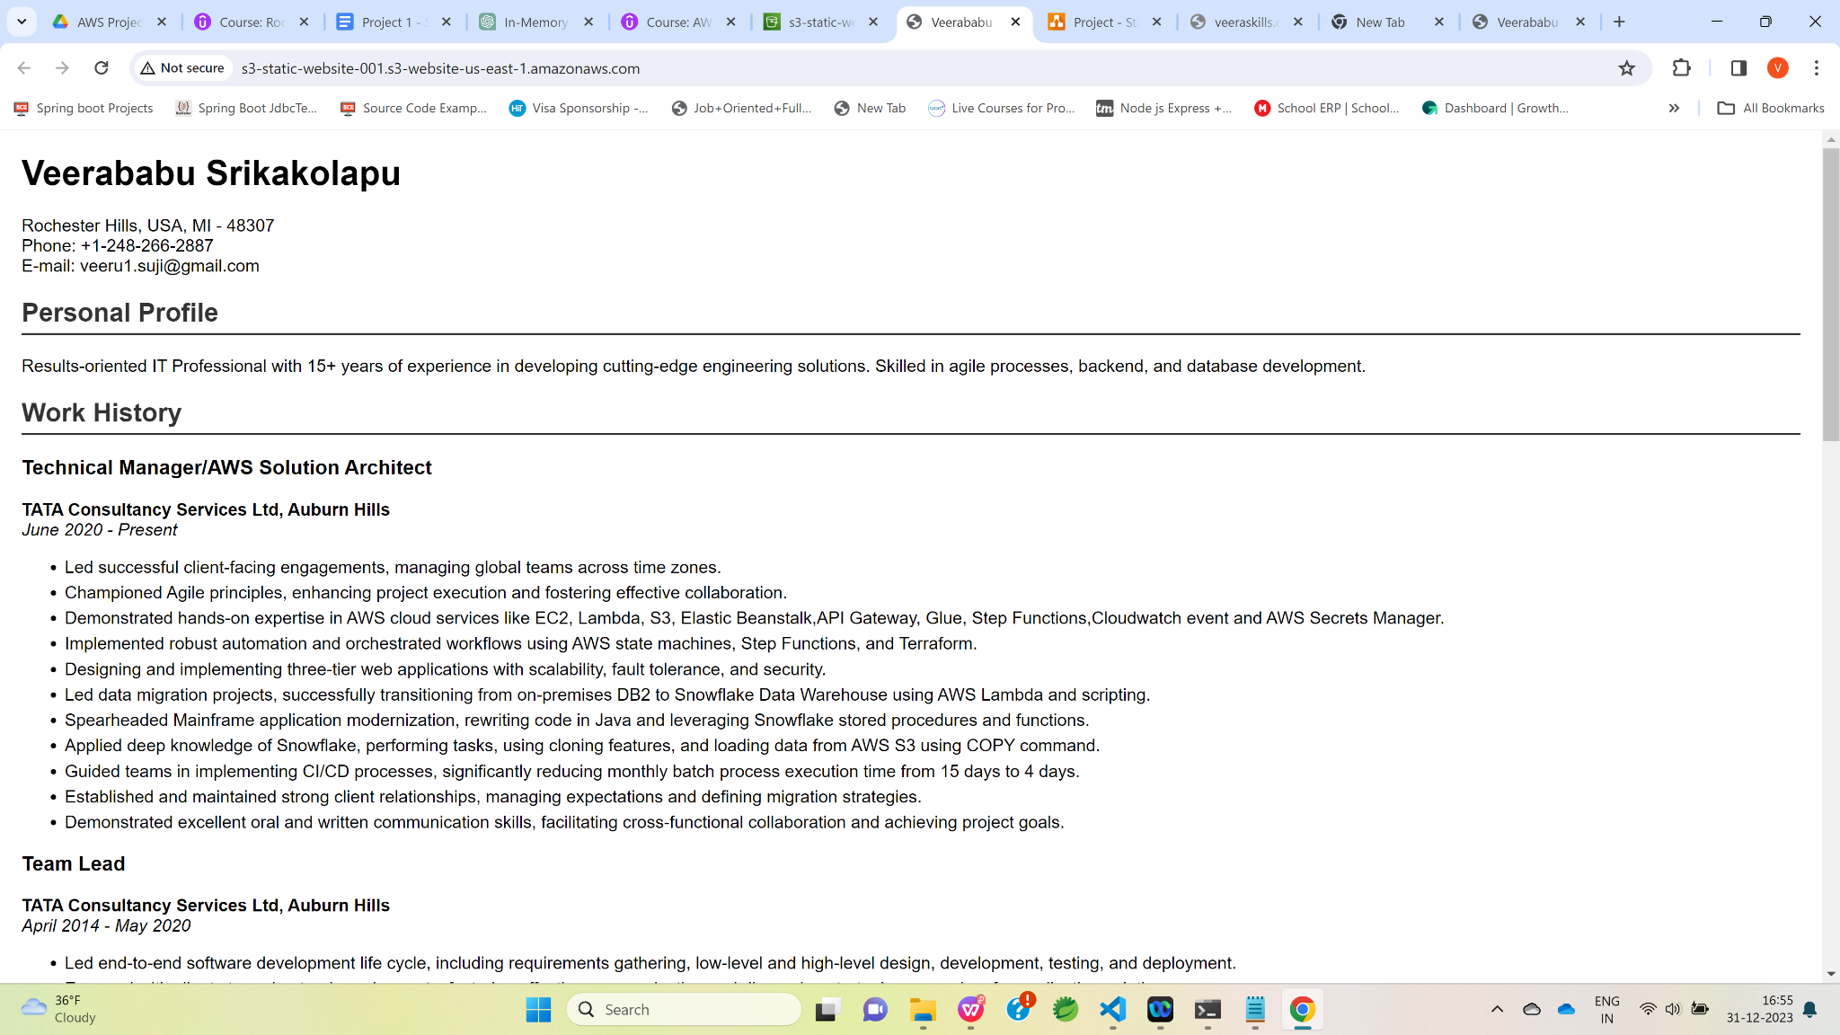

At this point , we are able to access the html resume successfully using S3 static website link.

Next ,we would be accessing this html resume using cloudFront.

Now , Let’s navigate to the AWS management console and click on CloudFront.

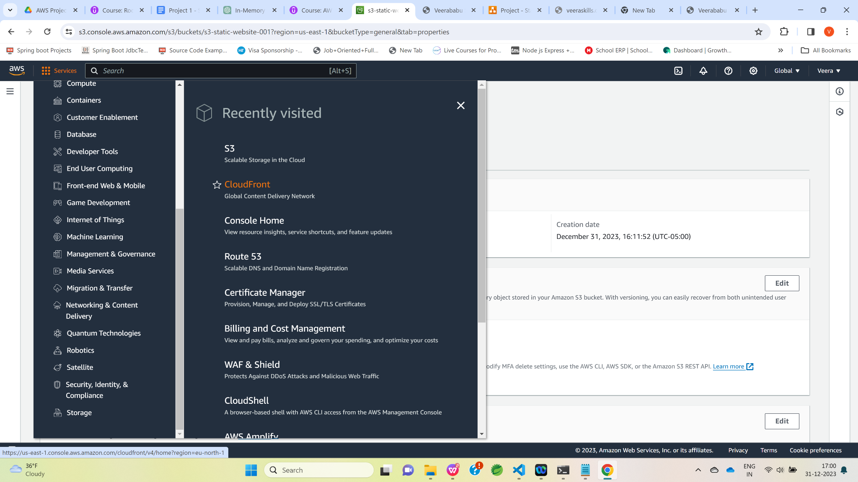

Click on “Create distribution” button.

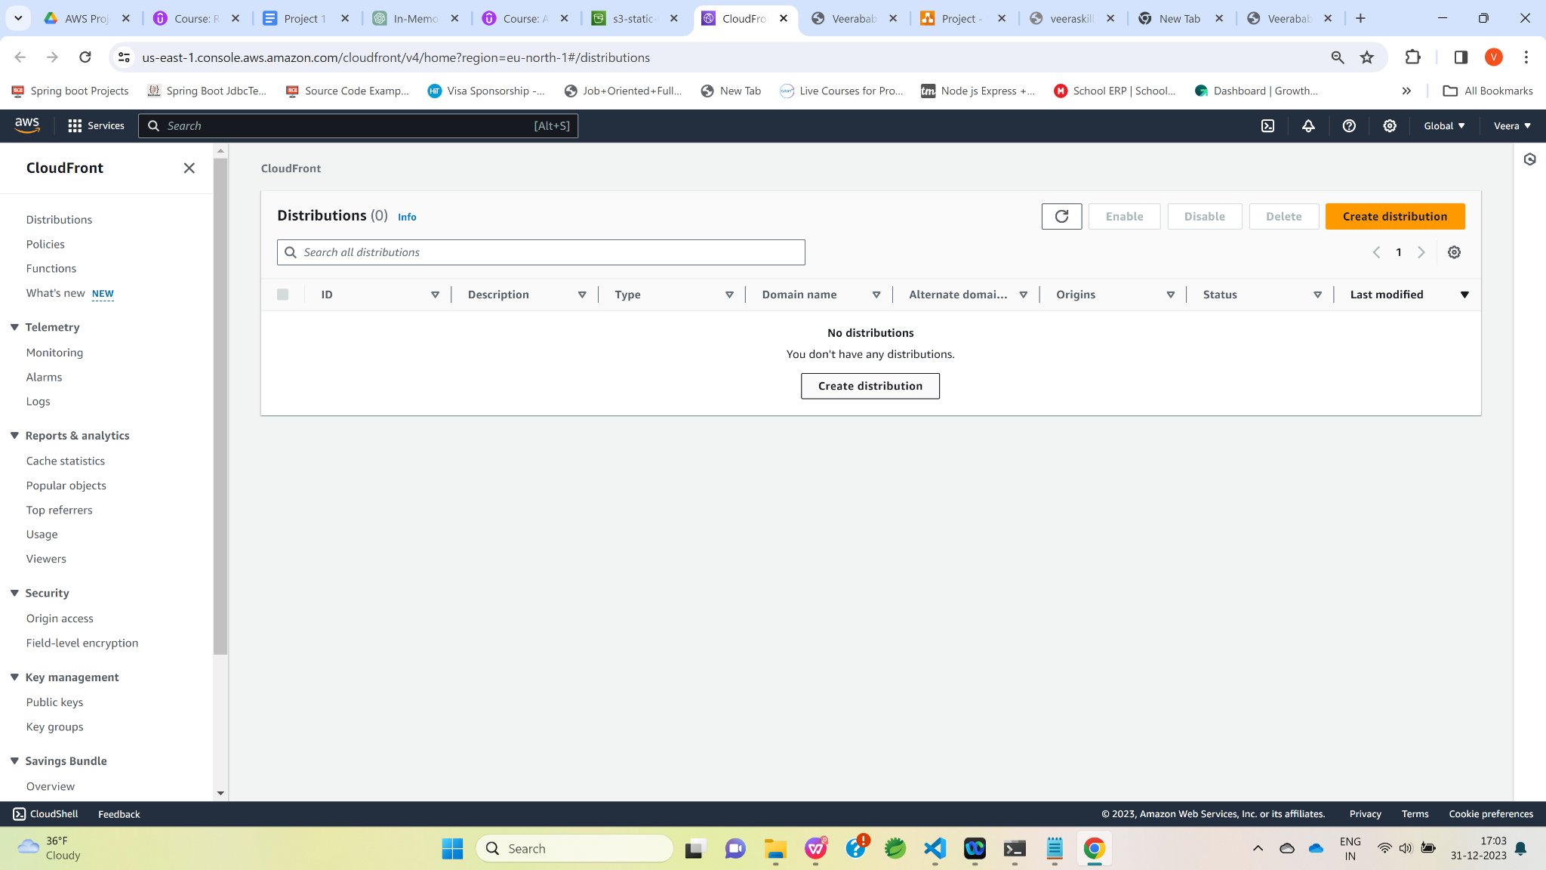

Enter S3 static website URL(s3-static-website-001.s3-website-us-east-1.amazonaws.com)

in Origin domain and Name textboxes.

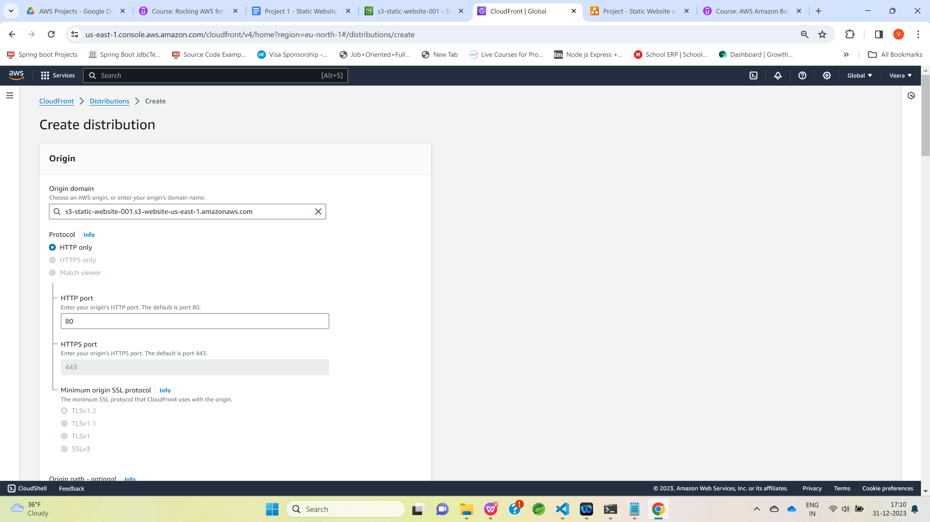

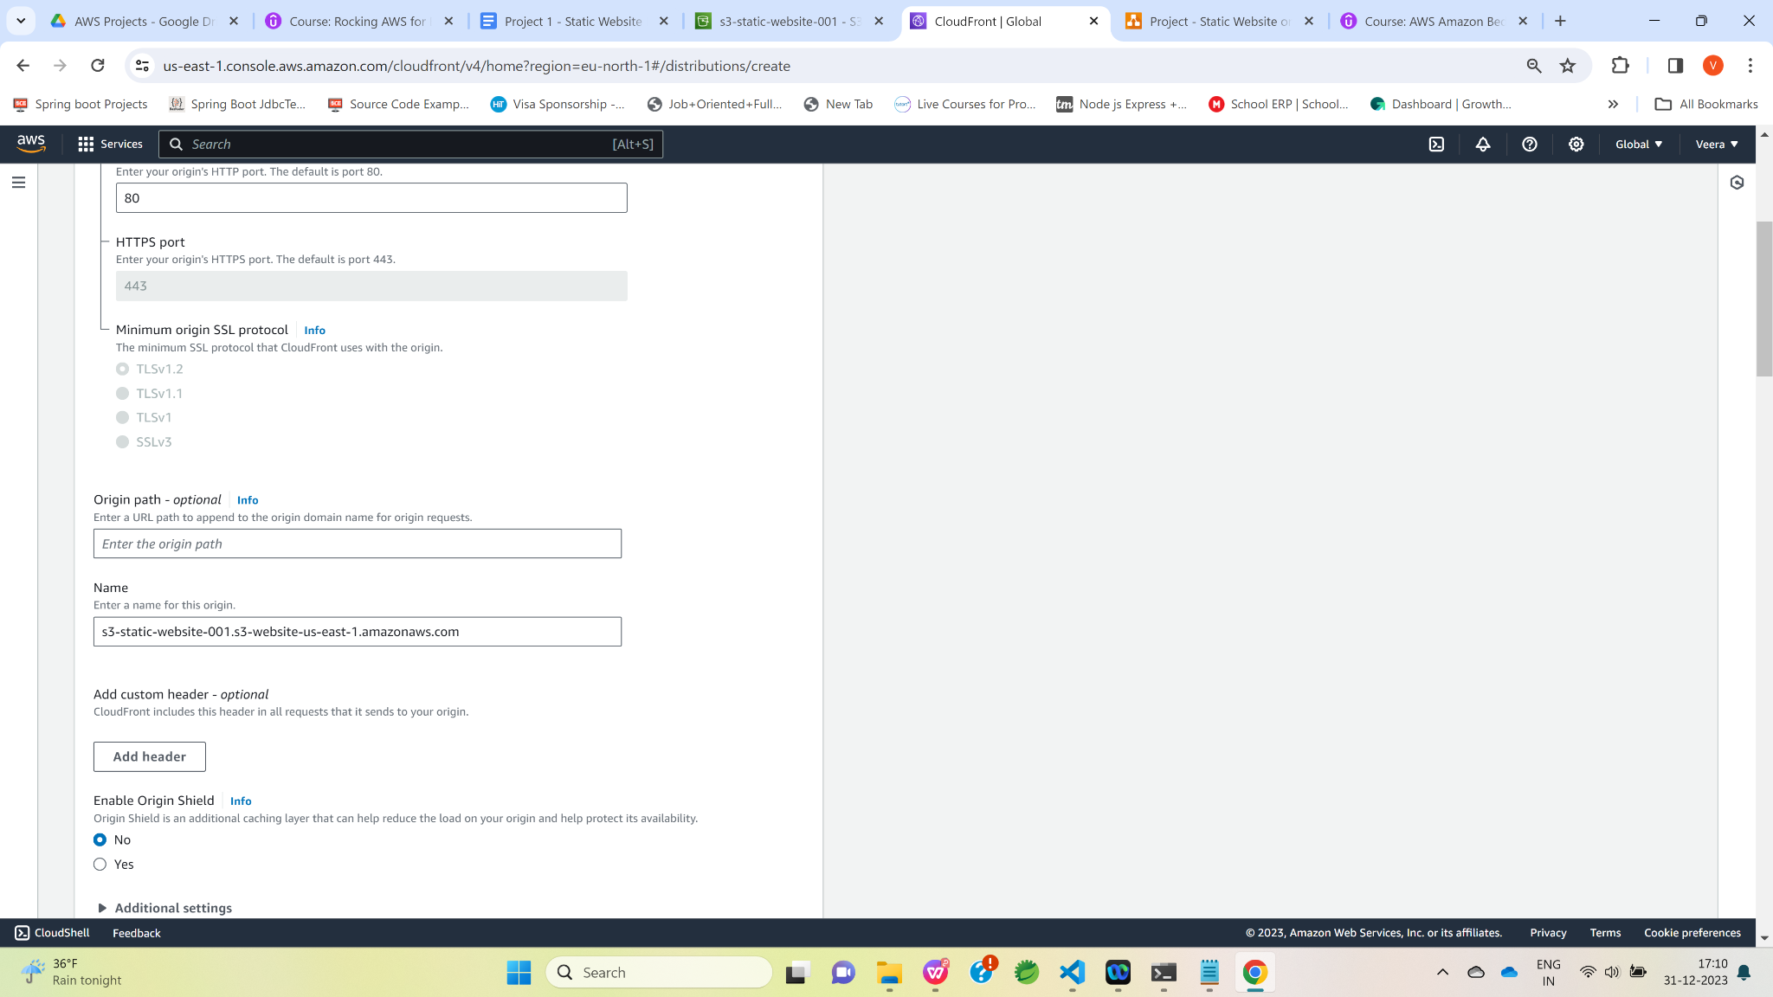

Select any security protection option in Web Application Firewall(WAF) section.

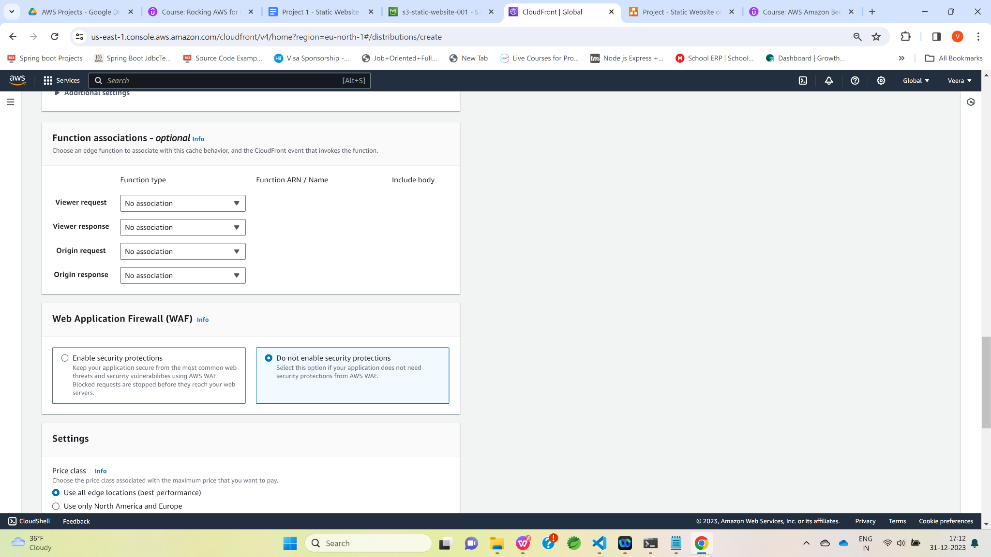

**Click on “Create distribution” button.**

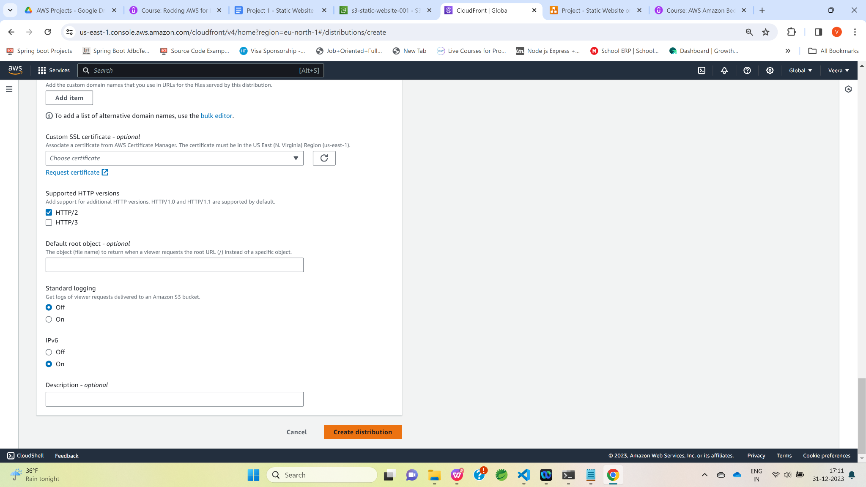

Now, CloudFront Distribution is getting deployed. It takes 4 to 5 mins for the deployment.

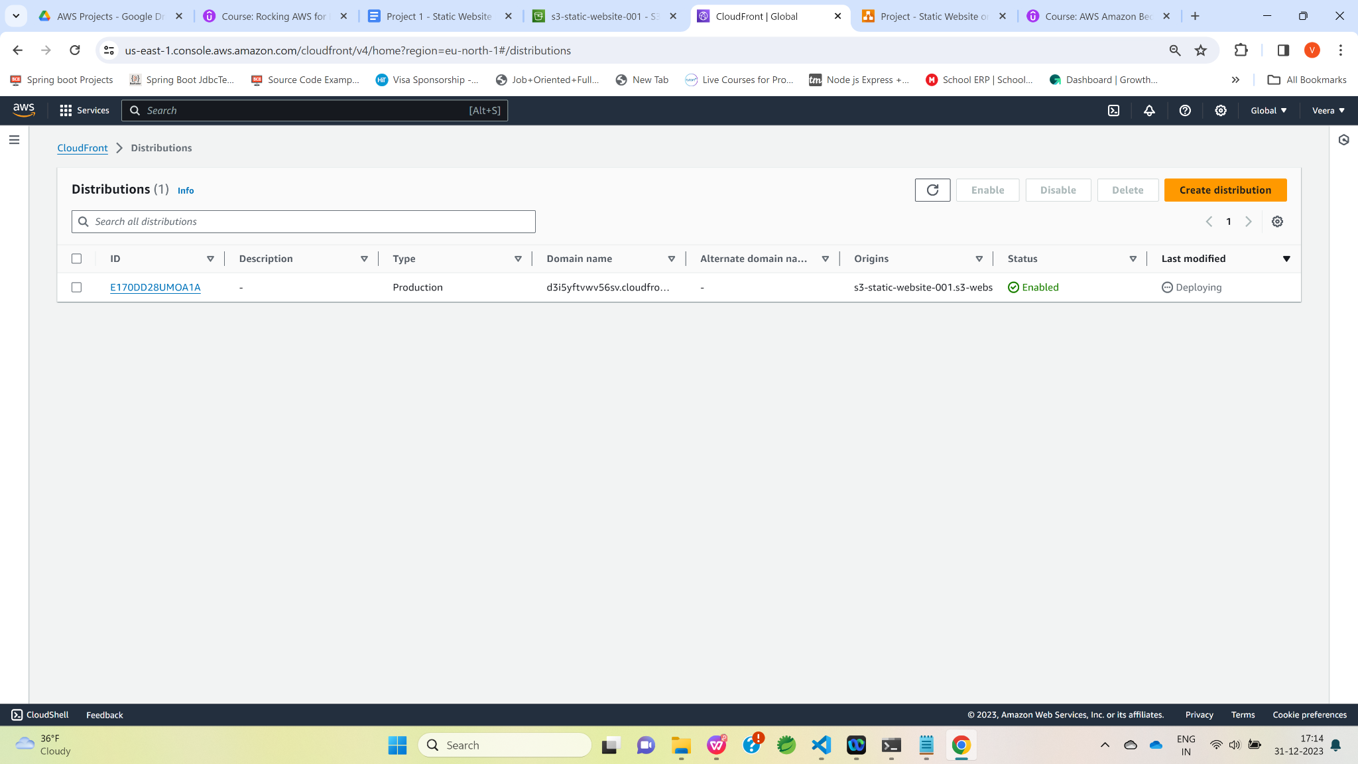

Once deployment is completed , click on Distribution ID

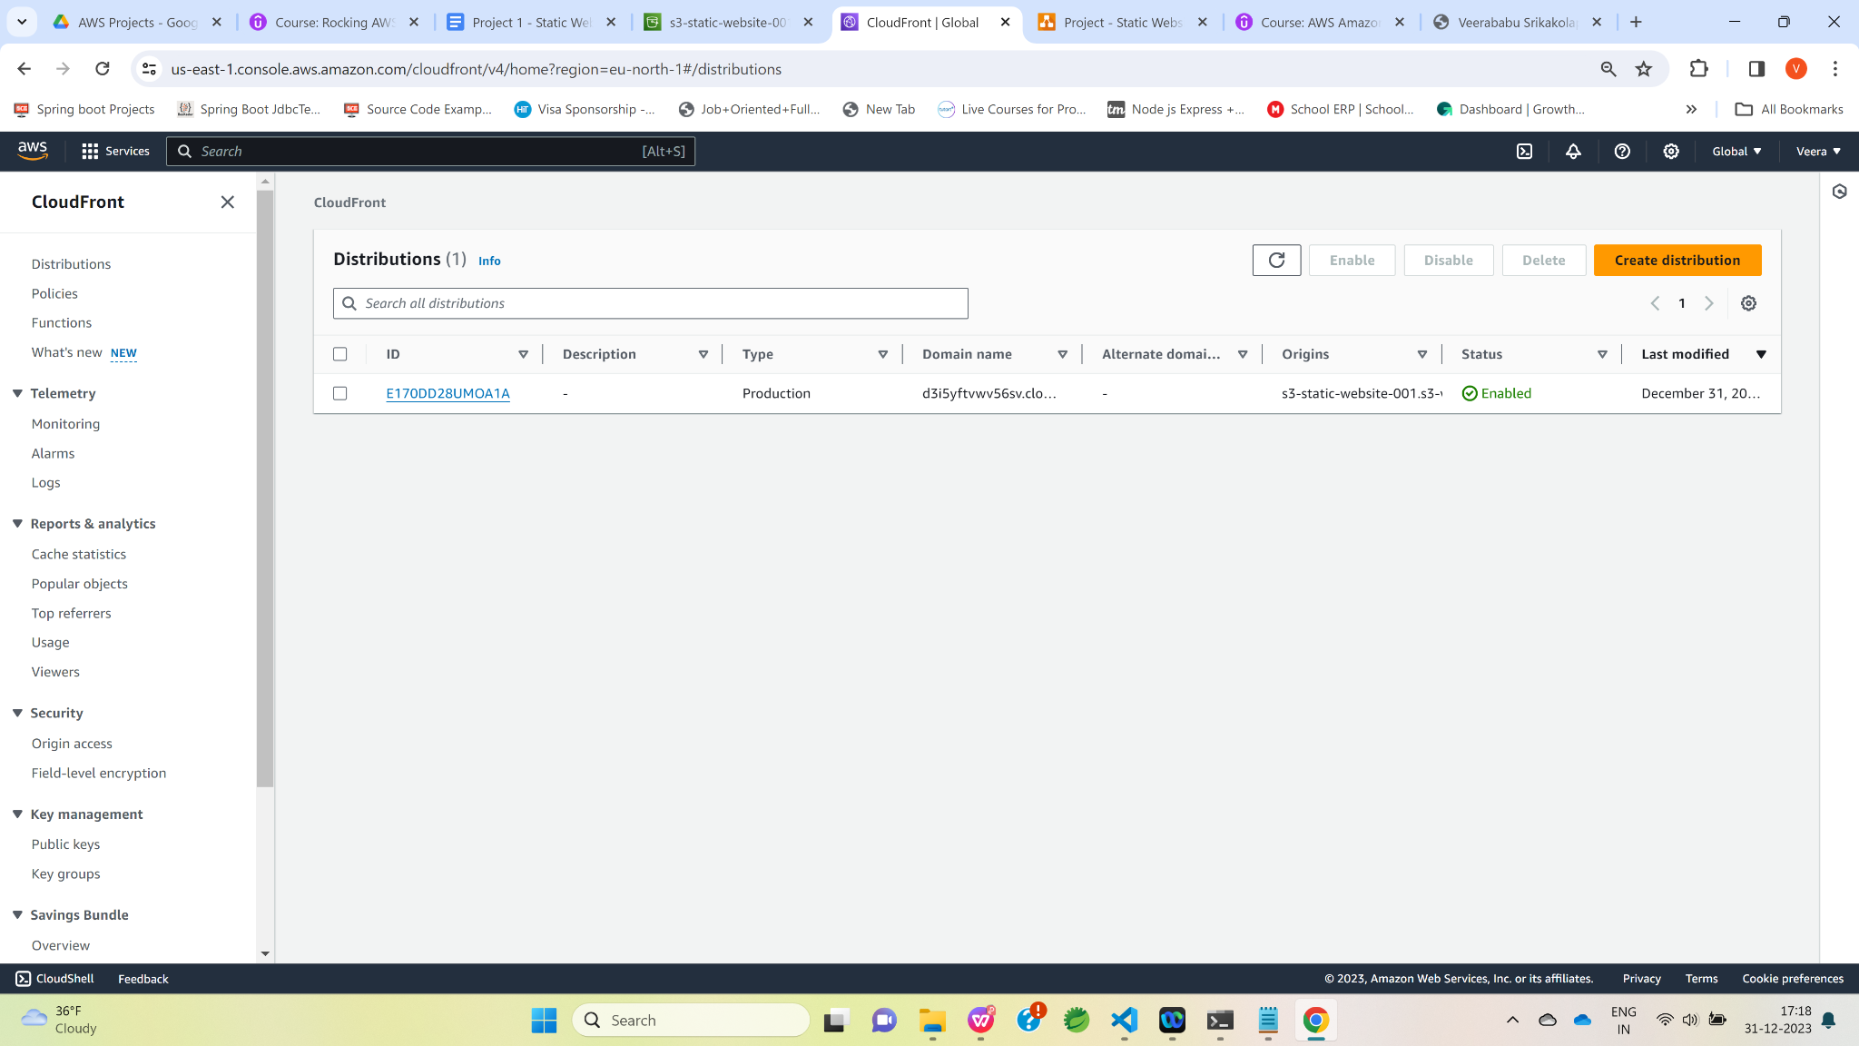

Copy Distribution domain name highlighted below and **open it from the new tab.html**

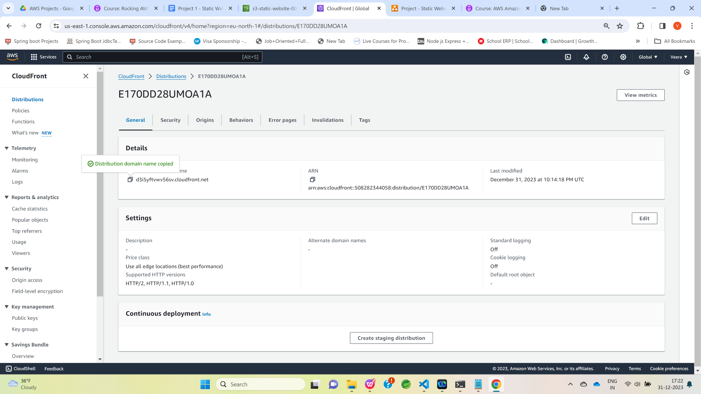

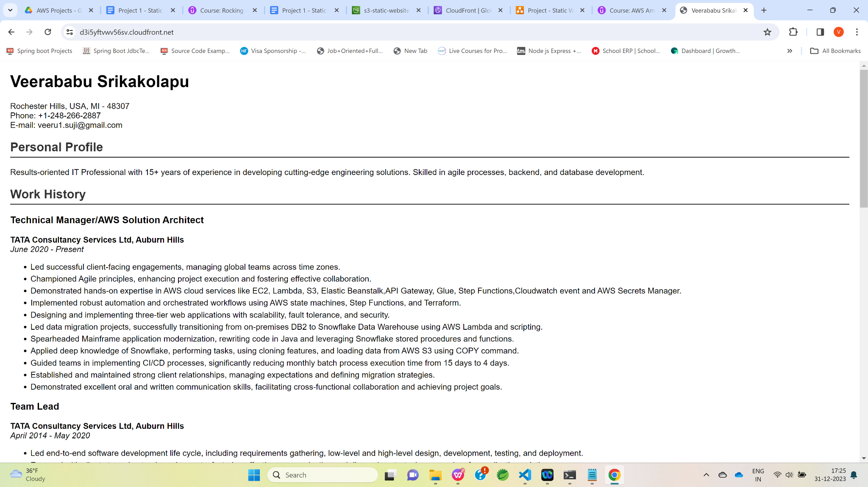



Next ,we would be accessing this html resume using AWS route 53 custom domain and CloudFront.

If we observe the URL of a S3 static website ,it is with **http not https** ([http://s3-static-website-001.s3-website-us-east-1.amazonaws.com](http://s3-static-website-001.s3-website-us-east-1.amazonaws.com/)**)** so , in order to access S3 website through Route 53 custom domain , we need to create SSL certificate and

attach to CloudFront distribution.

Navigate AWS management console and click certificate manager.

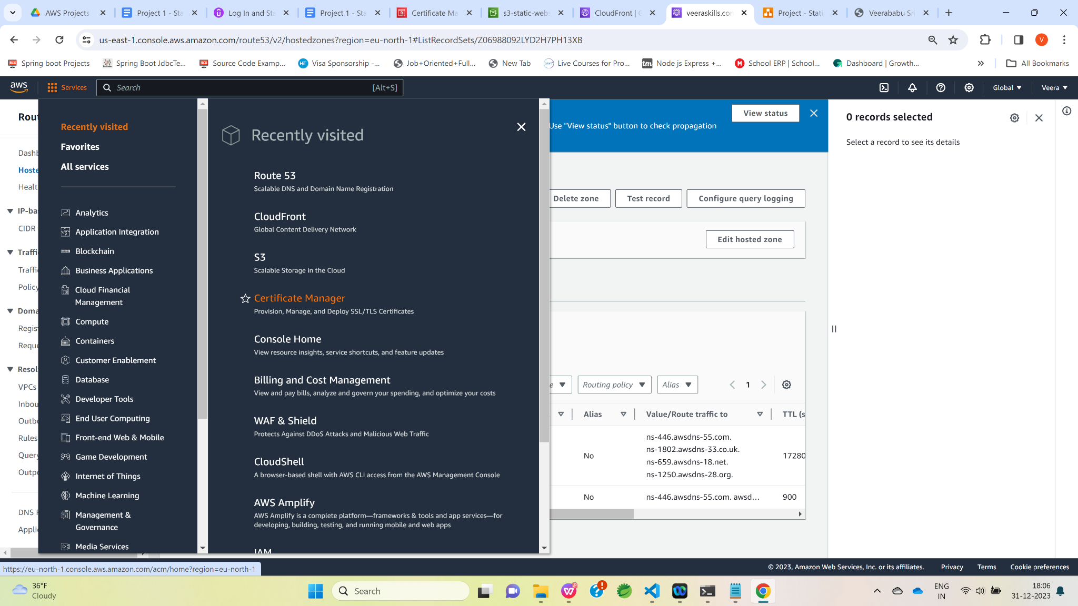

Click on “Request” button

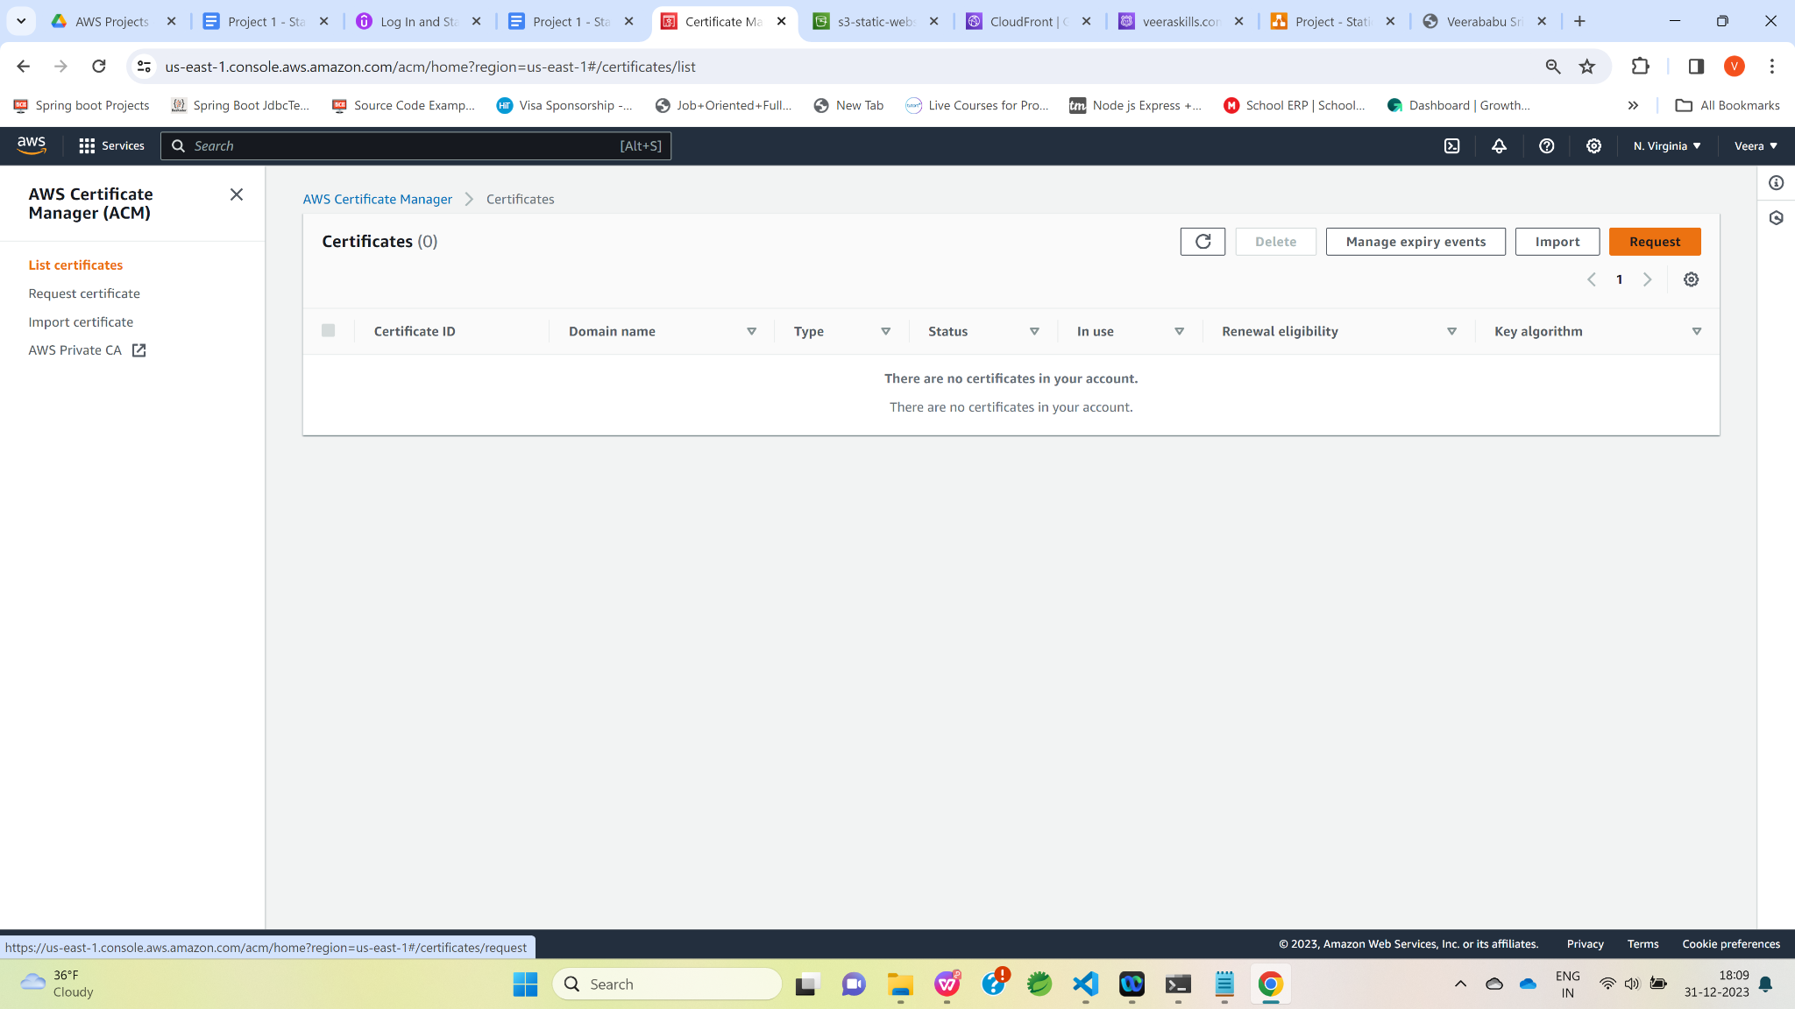

Select “Request a public certificate” and then click on “Next” button

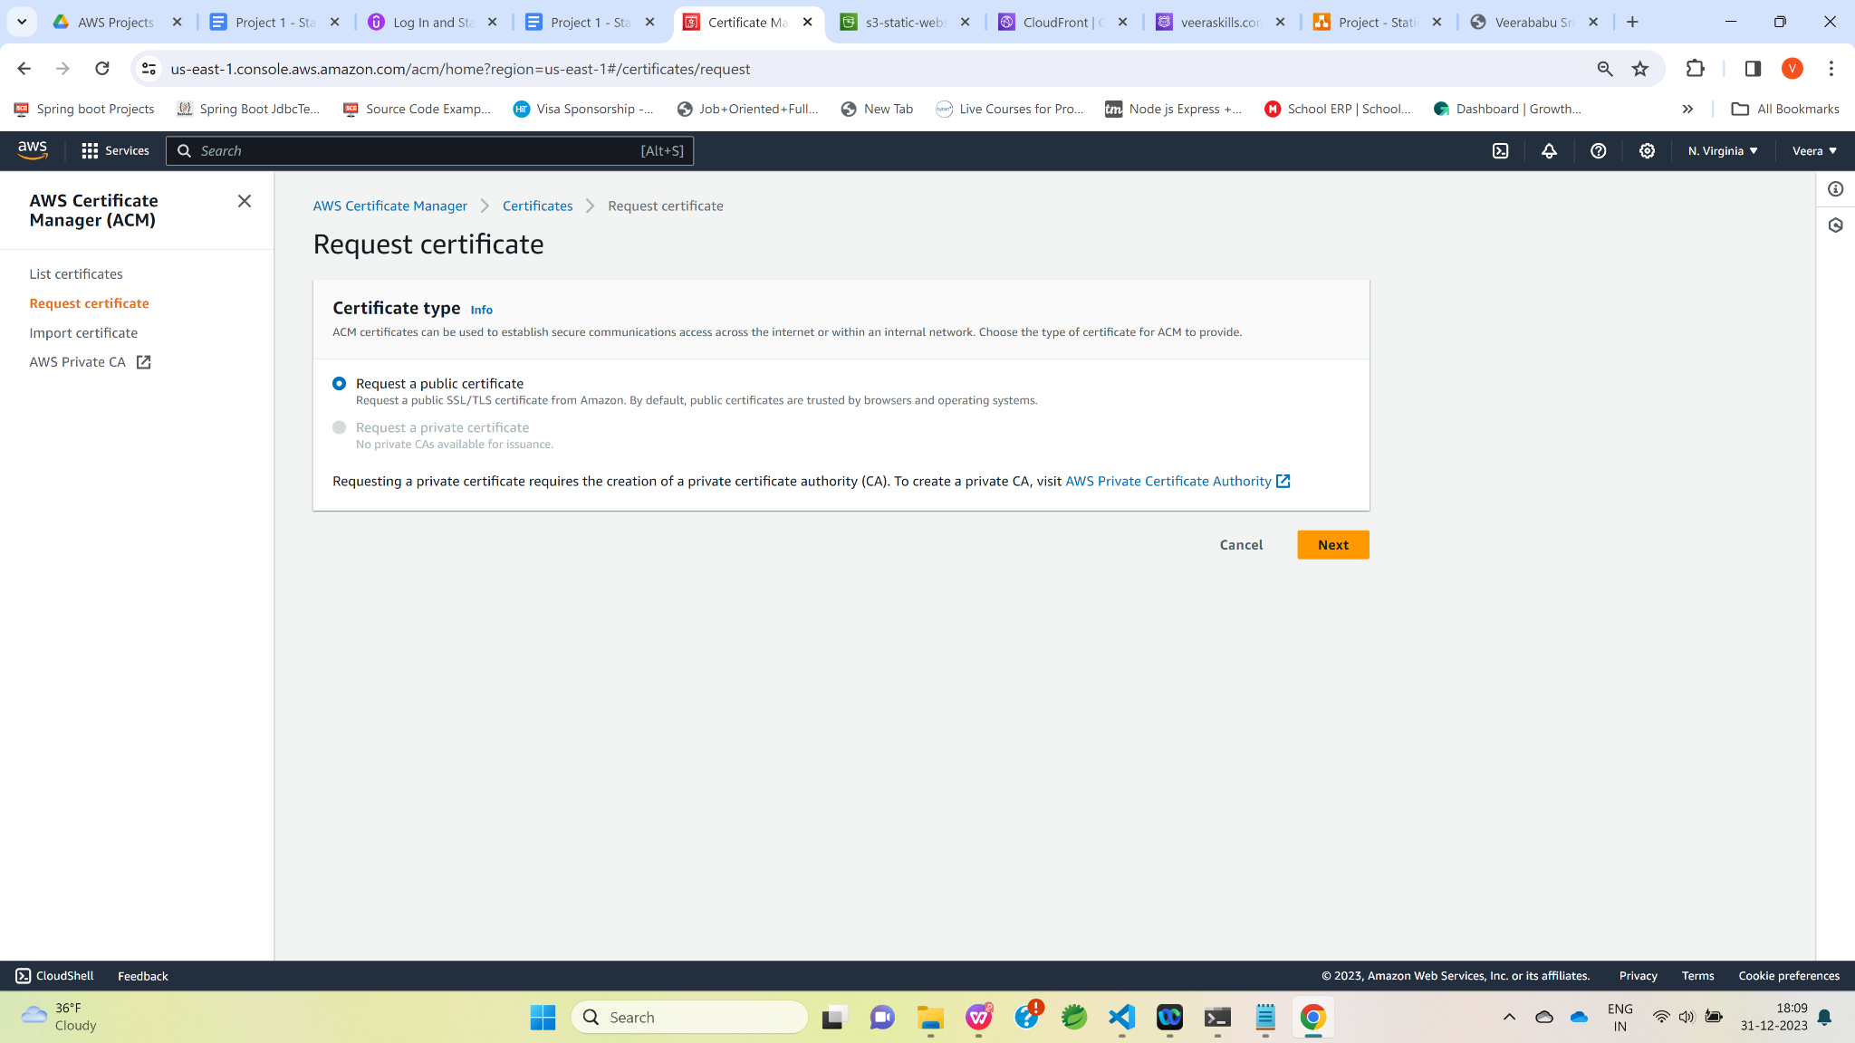

Enter custom domain name in “Fully qualified domain name” textbox.

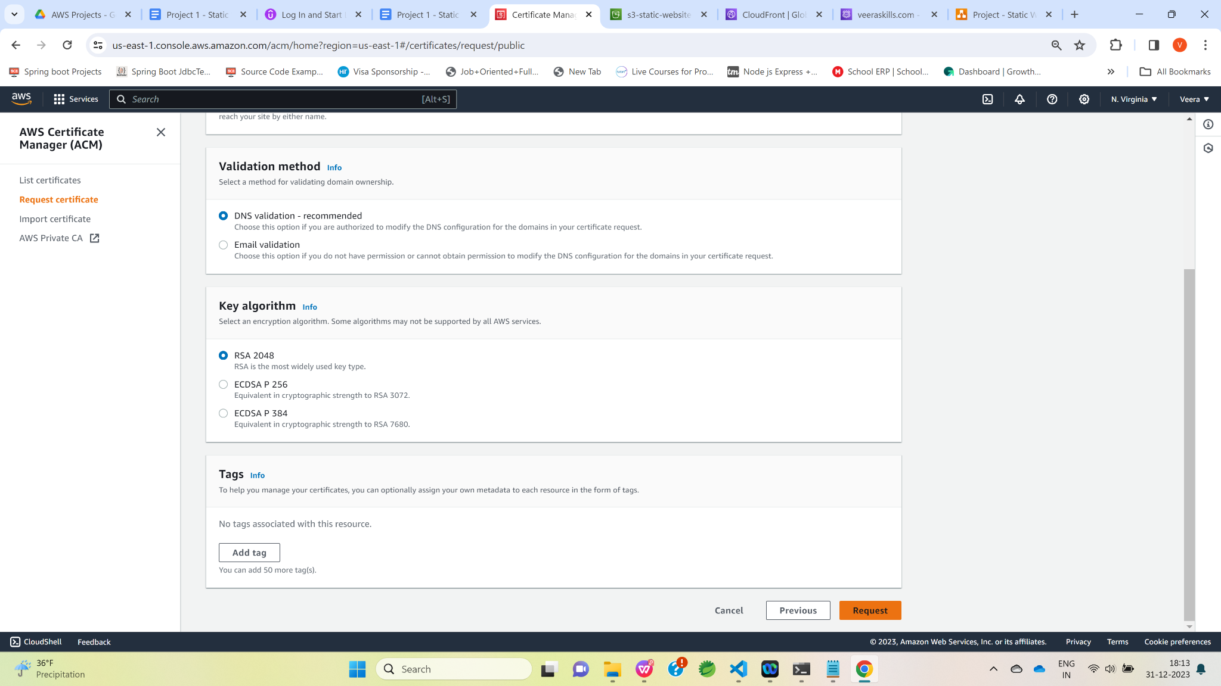

Click on “Request”

button

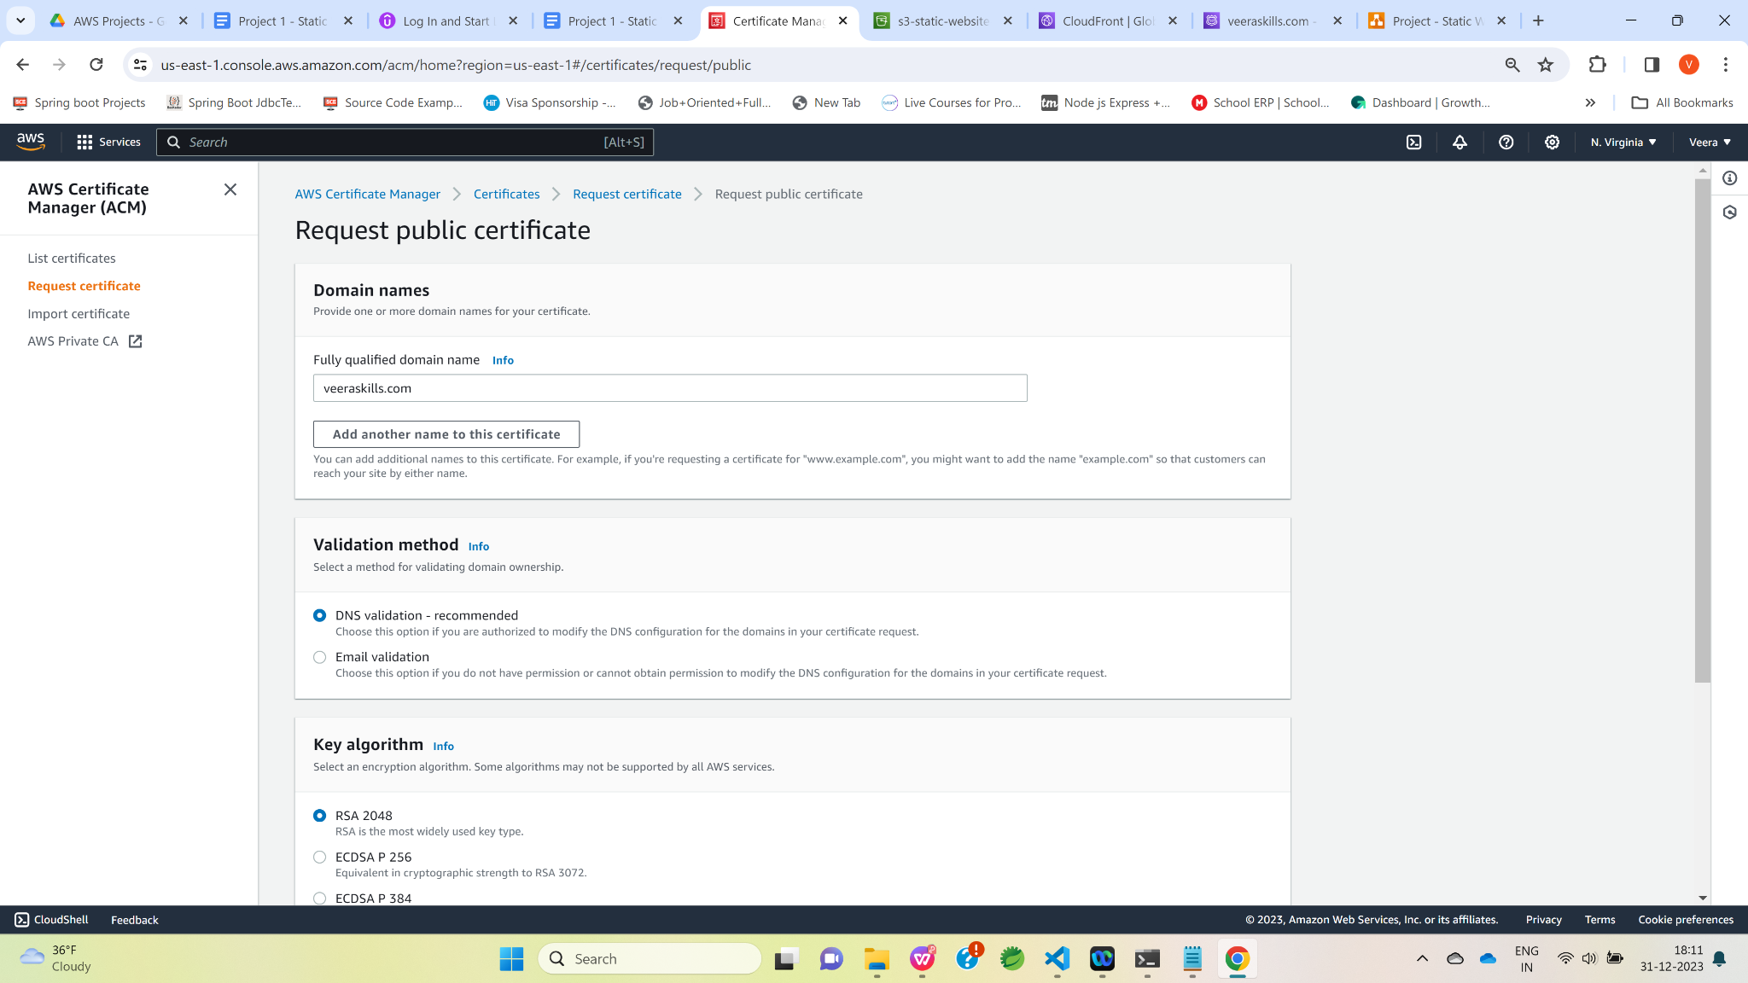

Now, certificate status is in Pending validation.

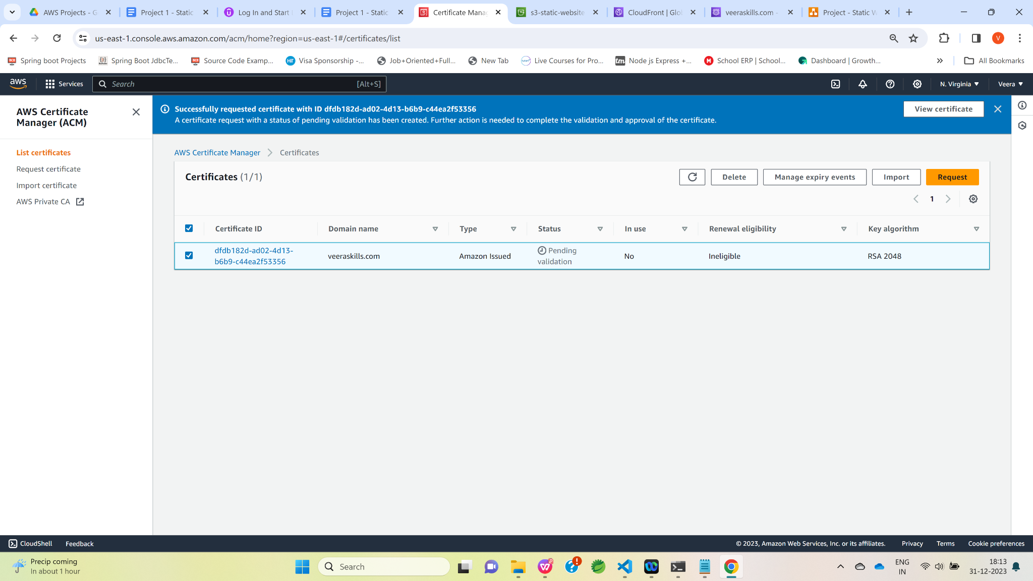

Click on Certificate ID and then click on the “Create records in Route 53” button.

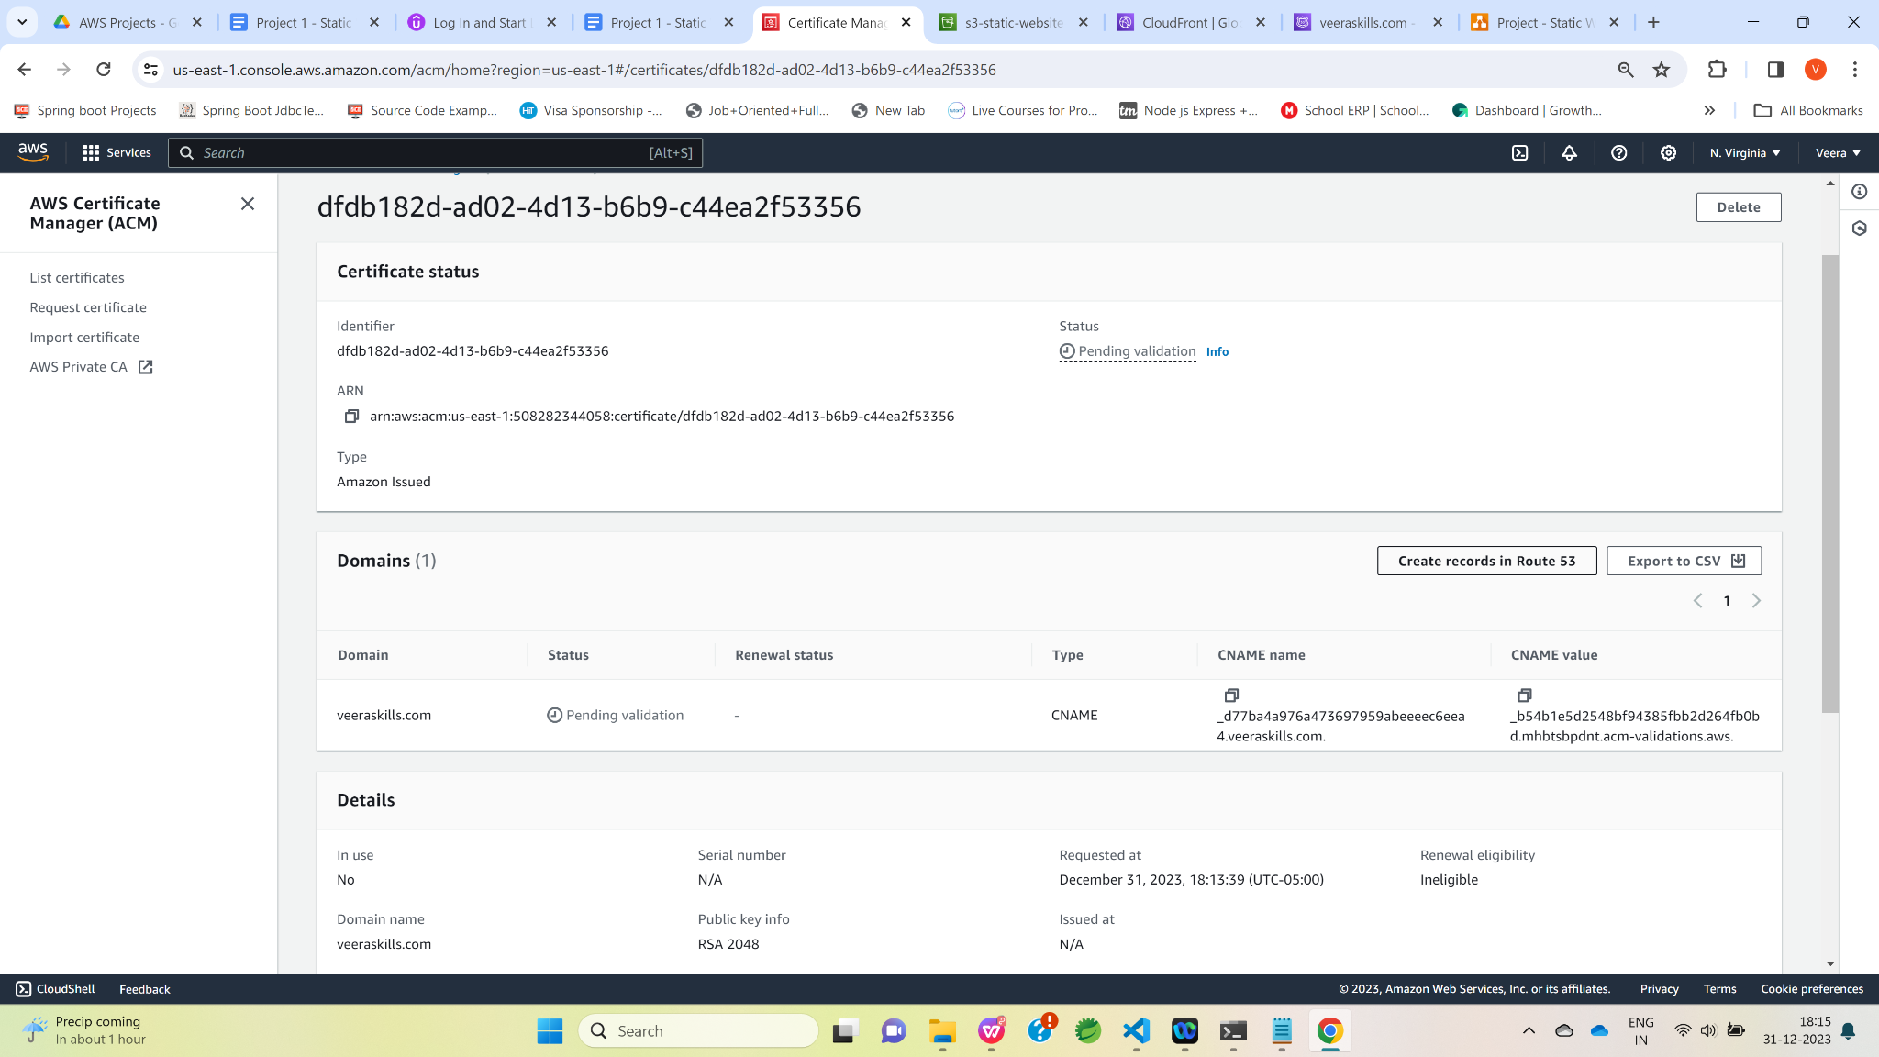

Click on “Create records” button.

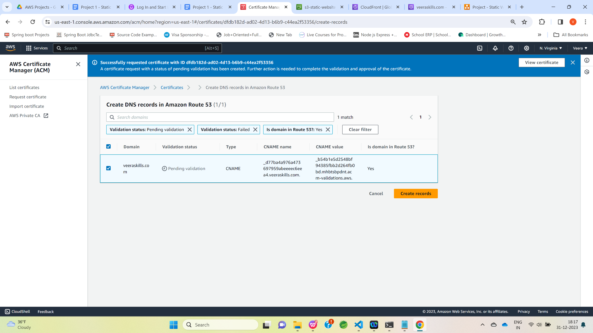

Now, certificate status has been changed to “Issued”.

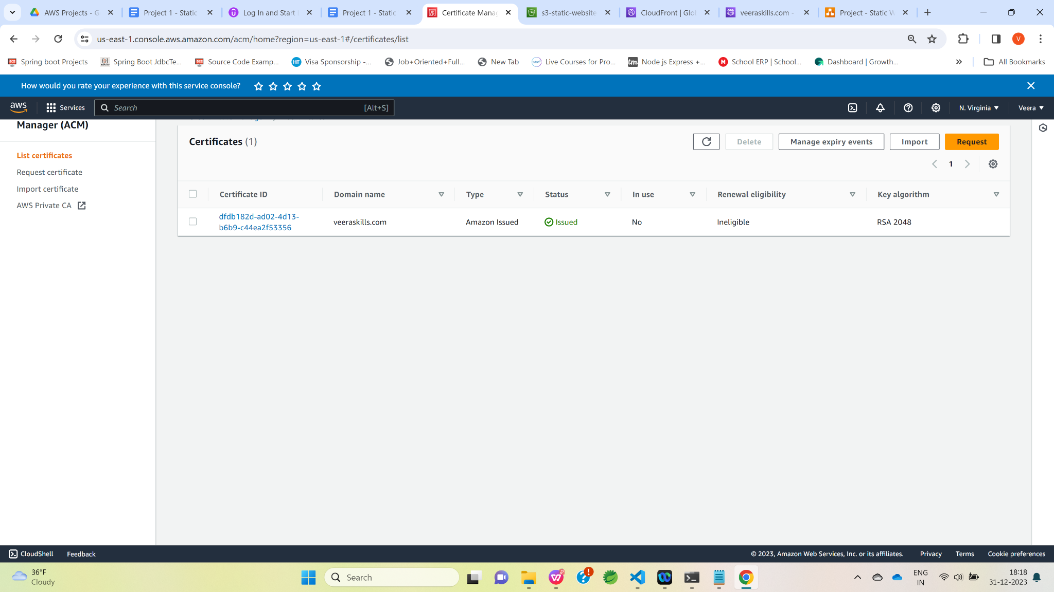

Now , let’s update SSL certificate and custom domain names in CloudFront distribution and click on “Edit” button.

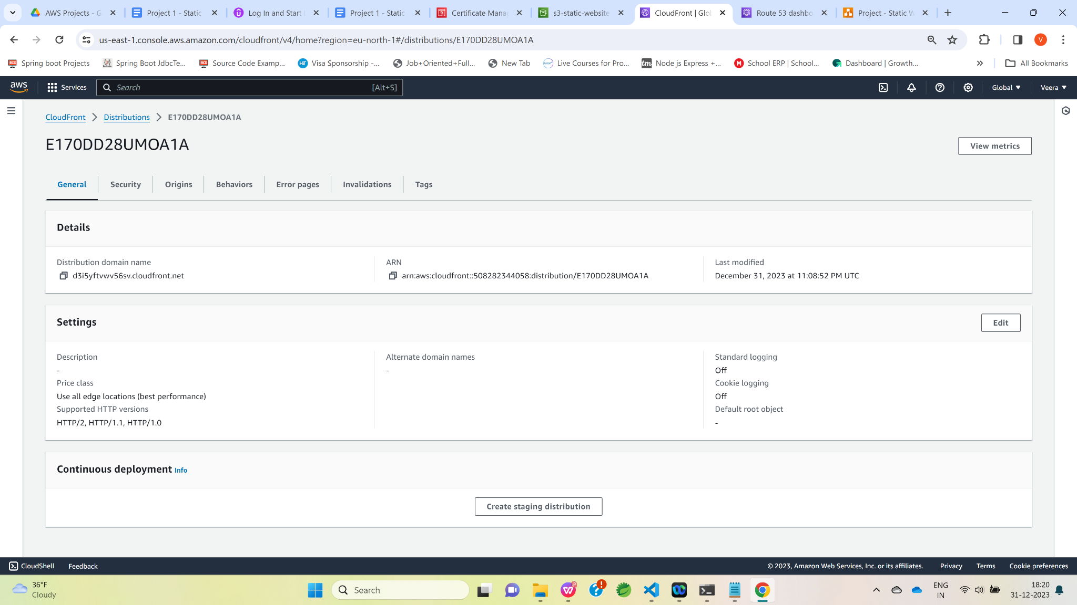

Enter custom domain name and then select certificate from Custom SSL certificate dropdown which was created above.

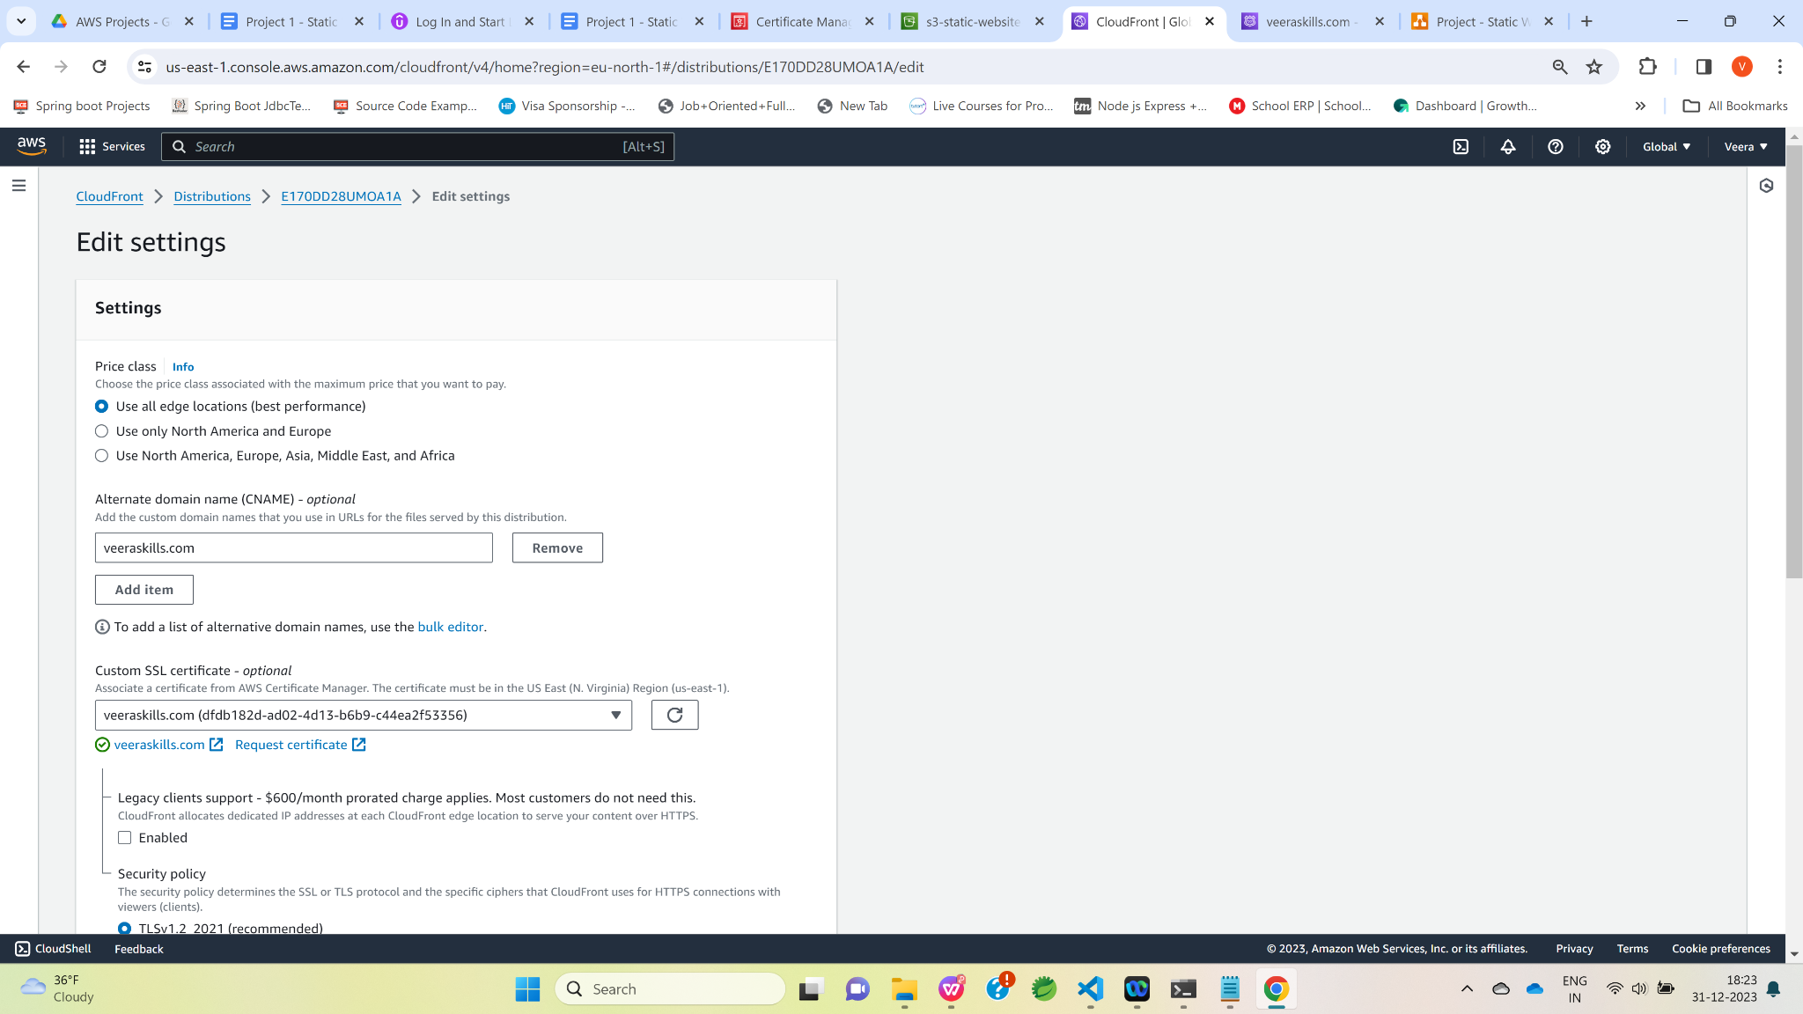

**Click on “Save changes” button.**

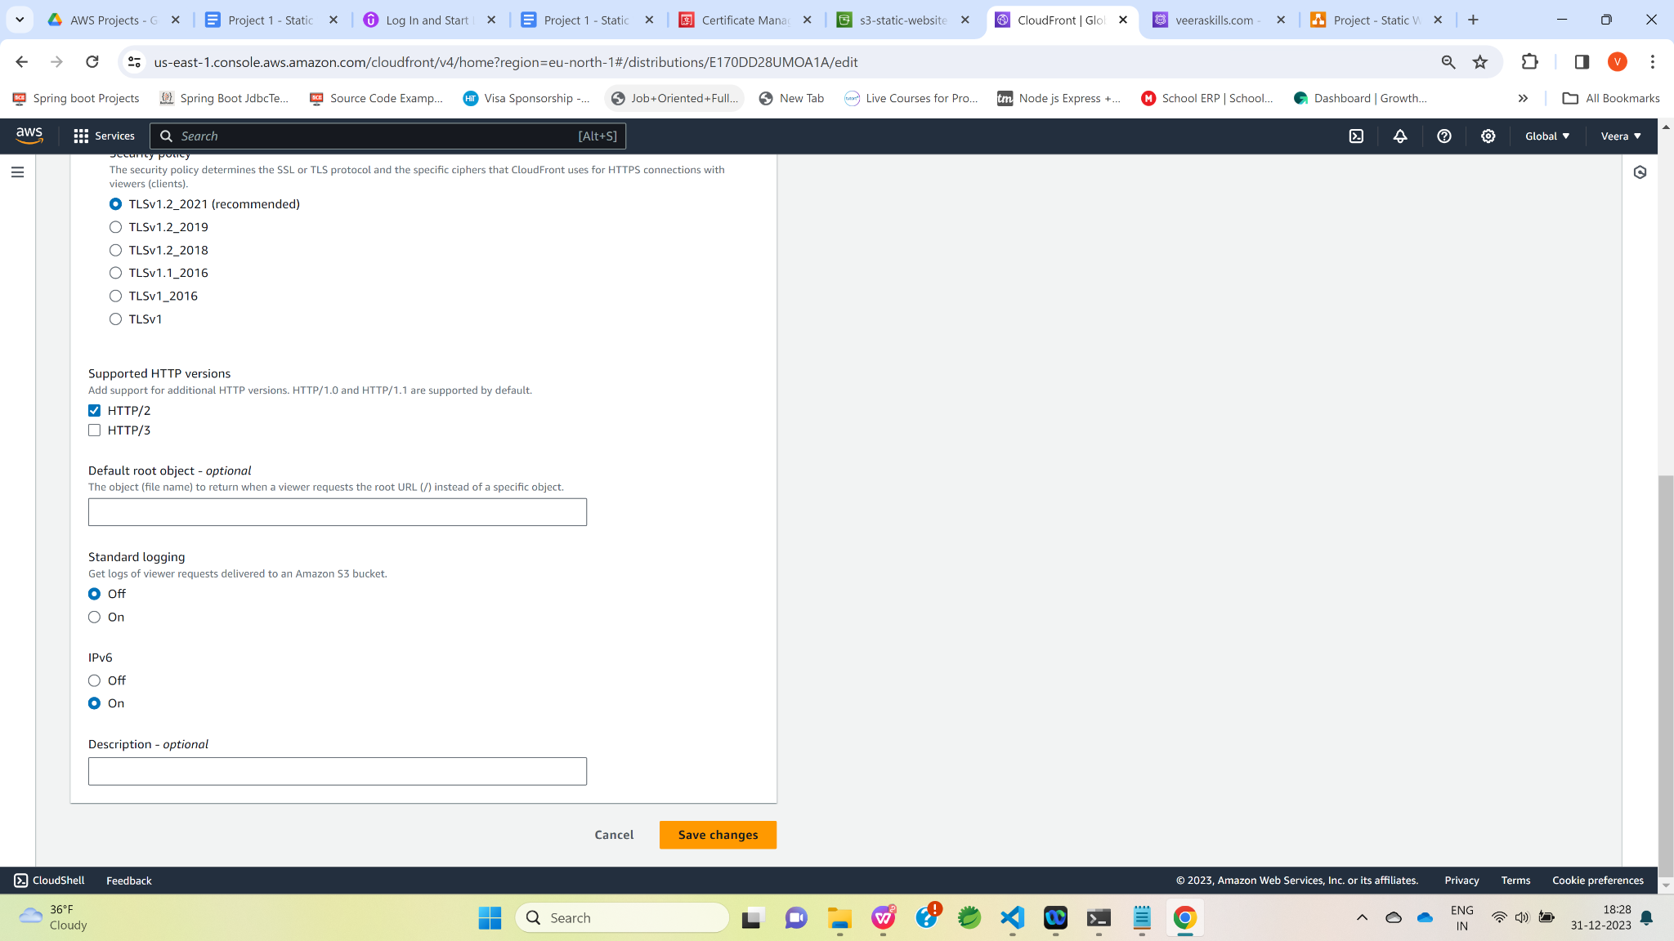

**Now , let’s map CloudFront distribution in Route 53 custom domain.**

**Click on Route 53.**

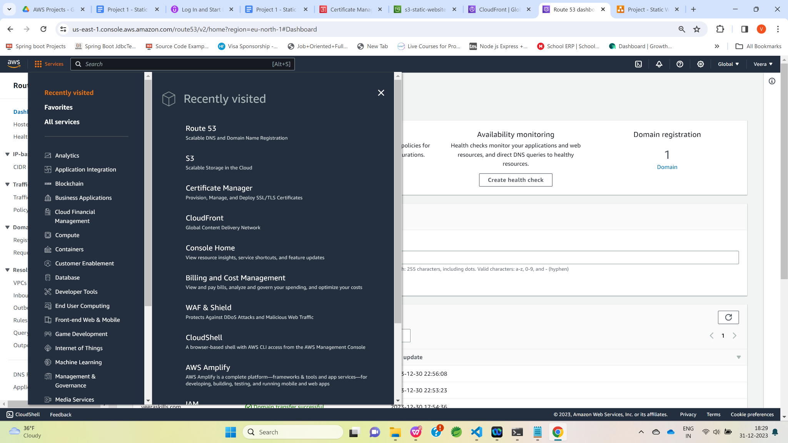

Click on “Hosted zones”.

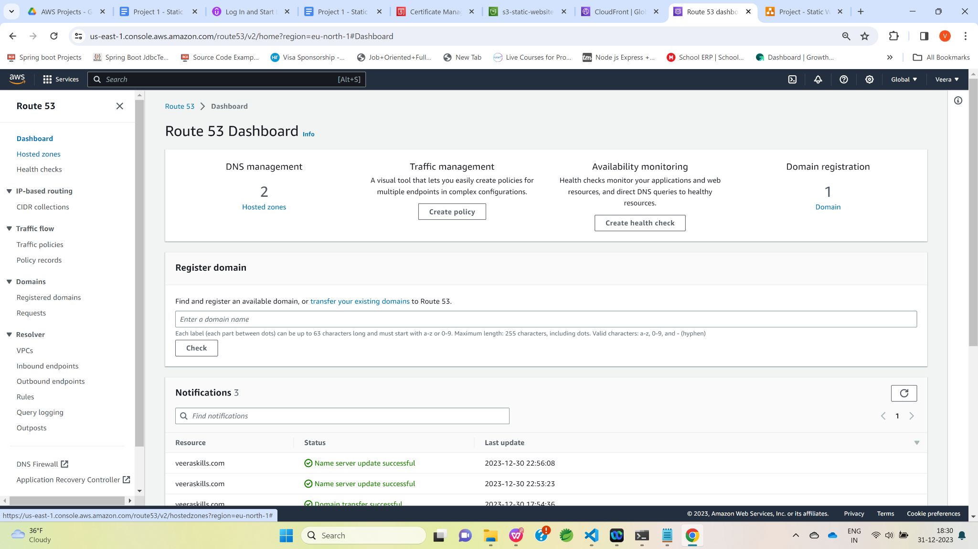

Click on the custom domain name.

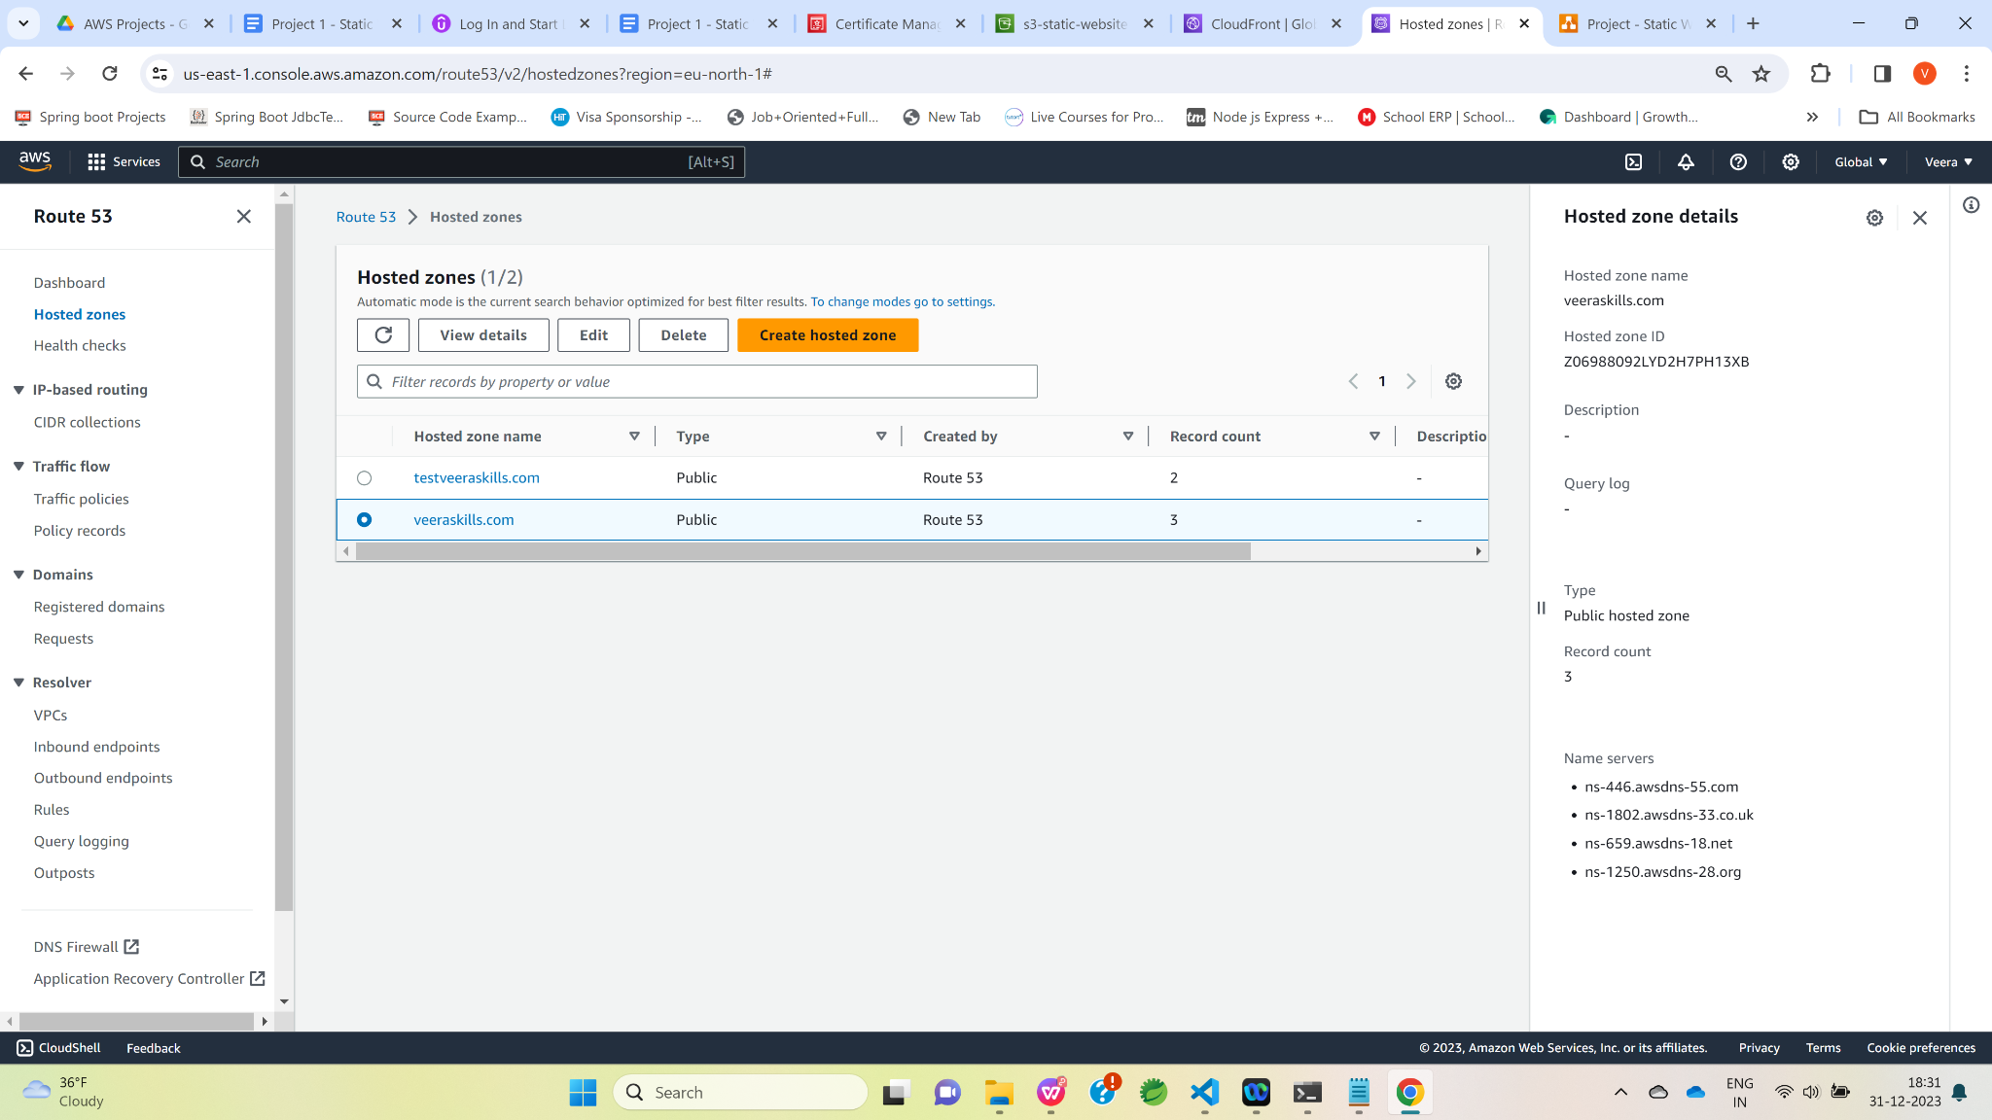

Click on Create record.

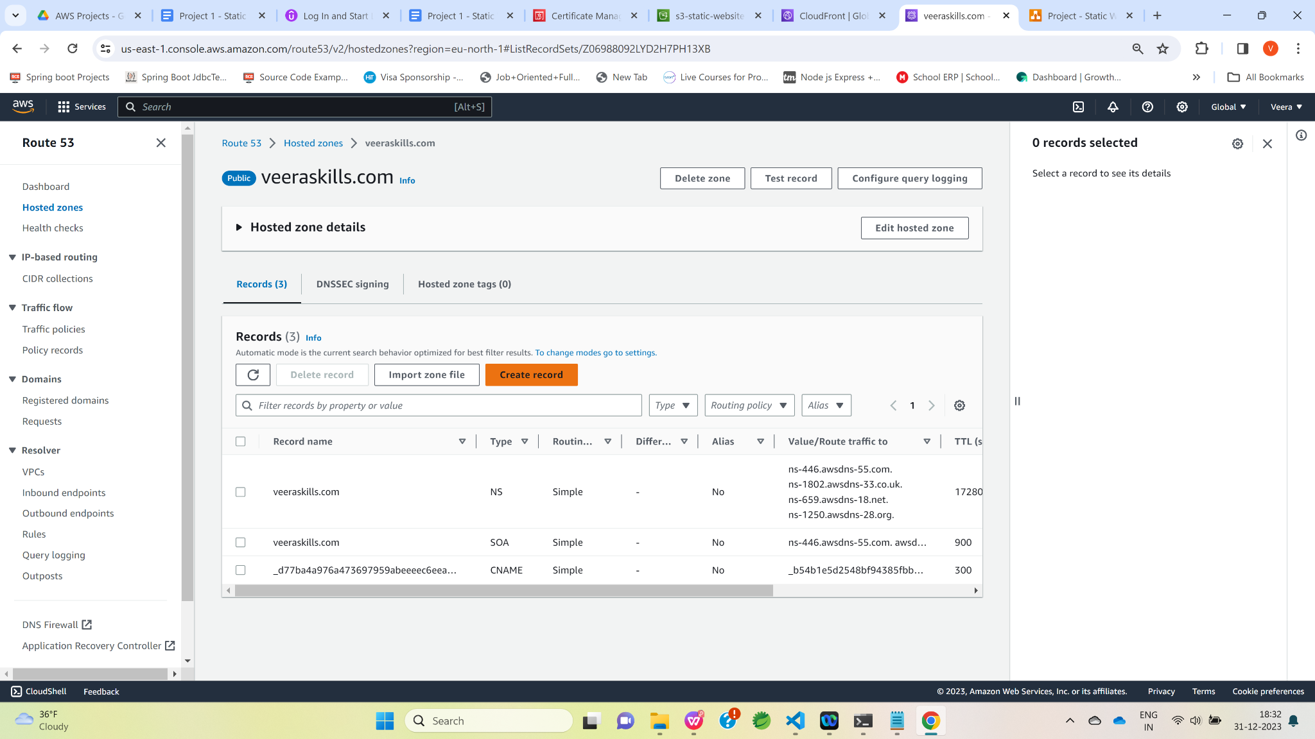

Select “Simple routing “ and click on “Next” button.

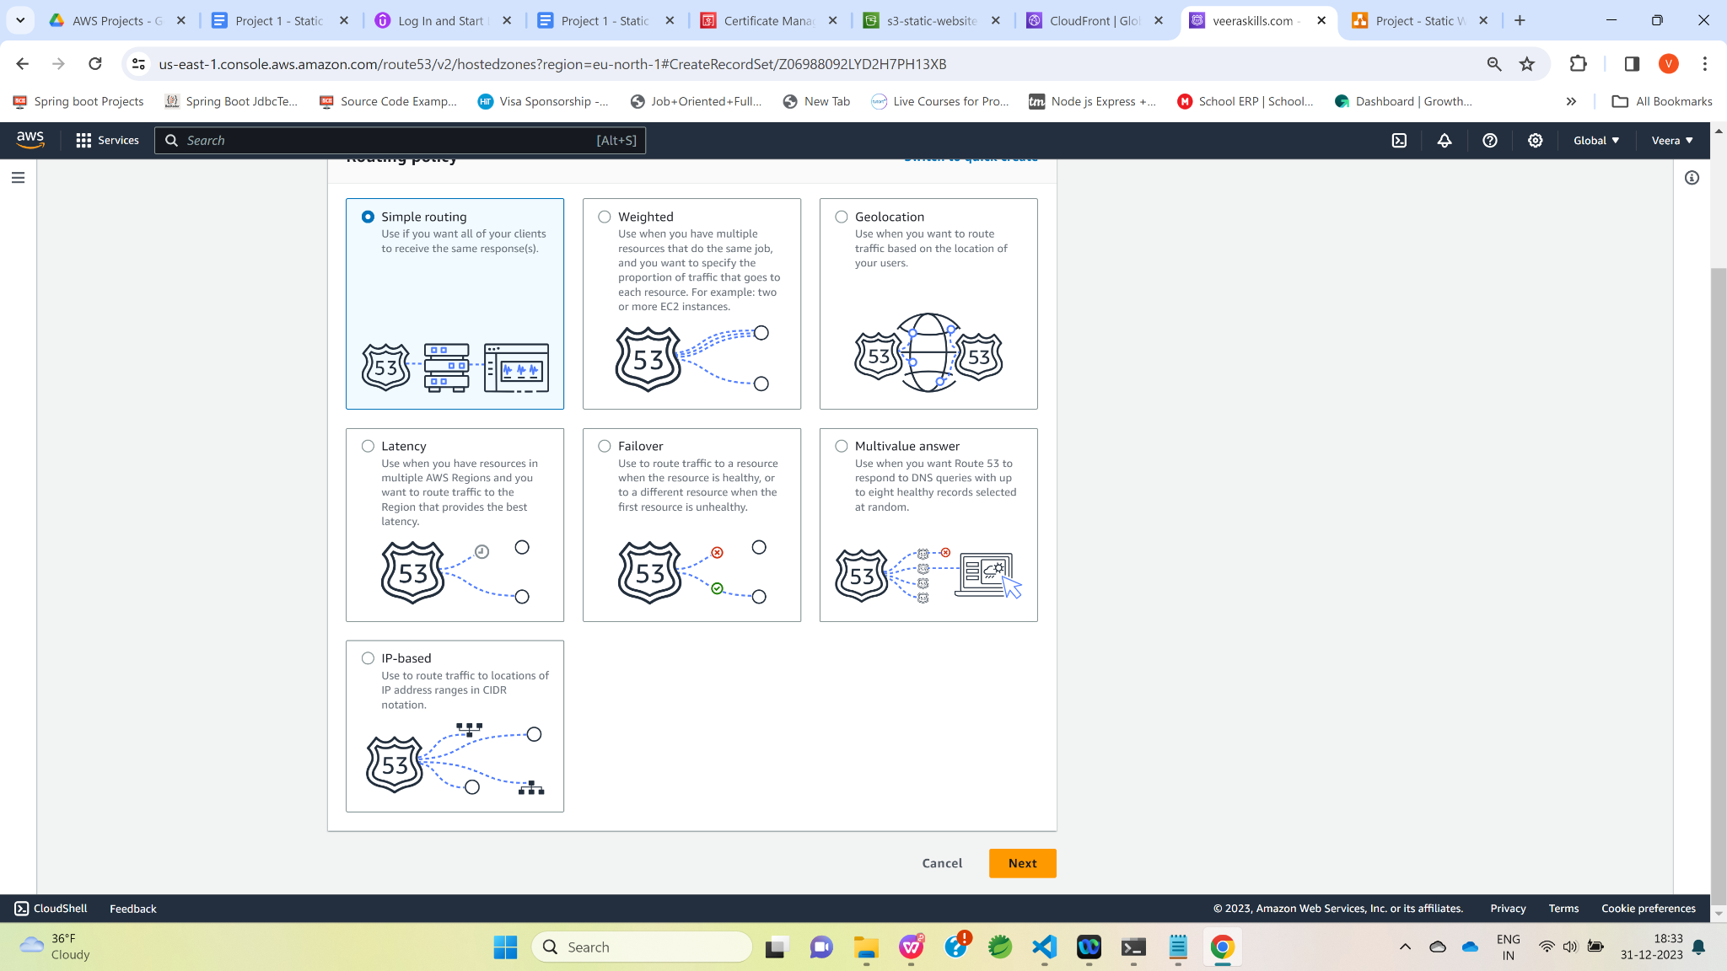

Click on “Define simple record”.

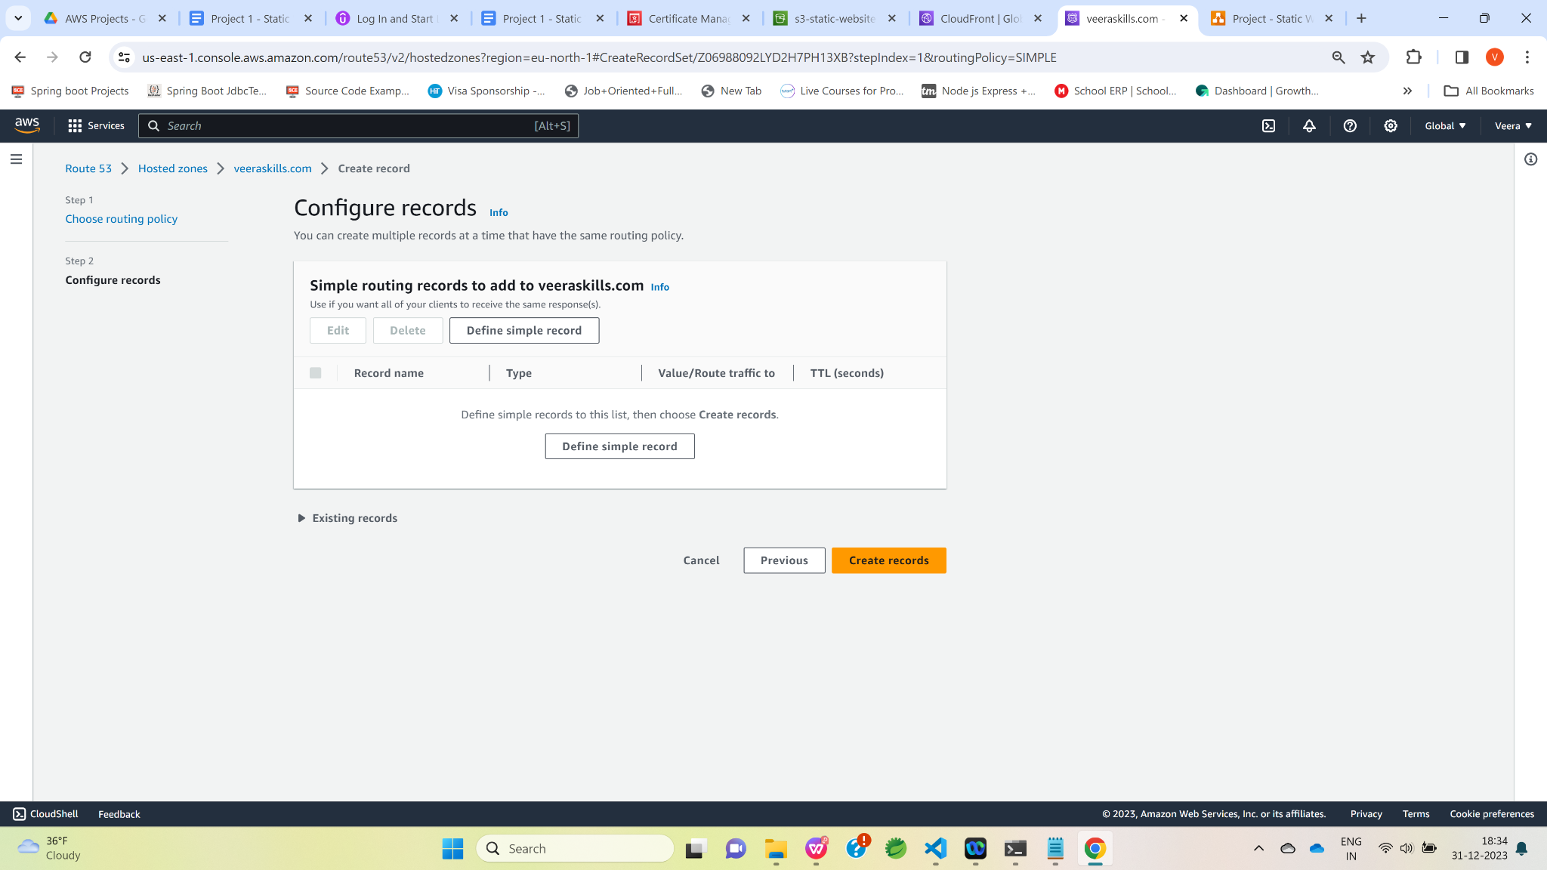

Select “A” type record from Record type Dropdown and select Alias to CloudFront distribution from Value/Route traffic to dropdown and then enter CloudFront Distribution domain name as shown below and then click on “Define simple record” button.

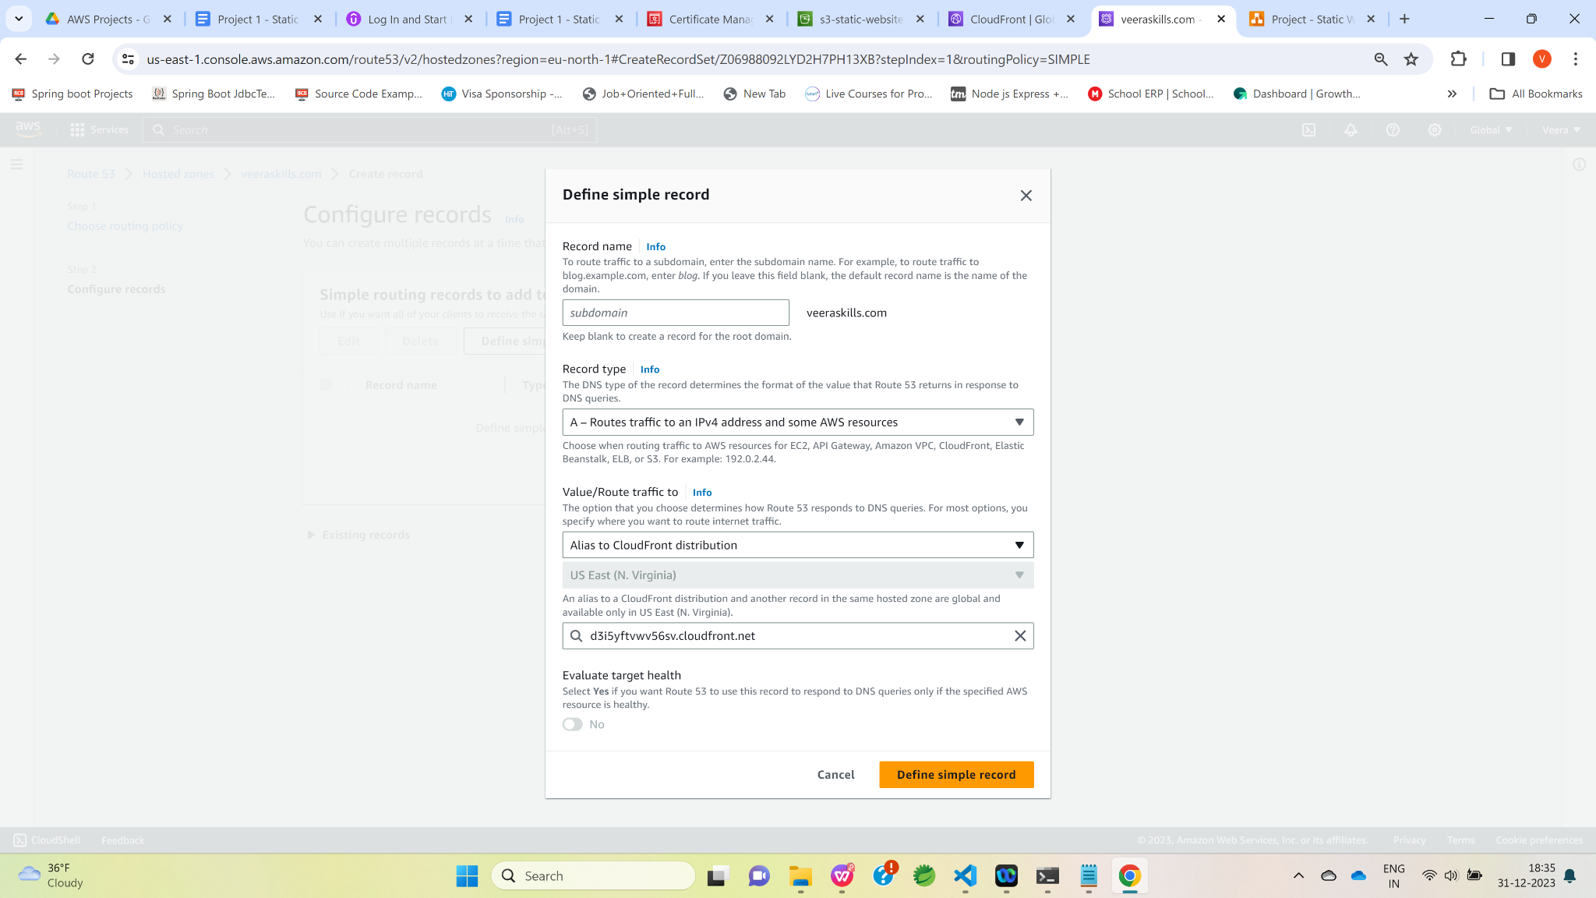

Click on “Create records” button.

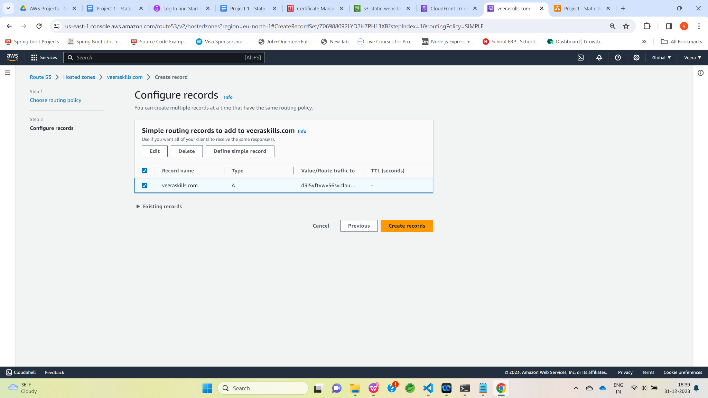

Open a custom domain name in the new tab.

Now,we are able to access resume successfully hosted as S3 static website using Custom domain and CloudFront.

